BASIC PHYSICS
Electricity & Magnetism
Book 1 of the Electrical Engineering Foundations Series
A first course in the physics that everything else in electrical engineering is built on.

Preface — How to Use This Book
This is the first book in a series that walks through electrical engineering from the ground up: physics first, then circuits, then devices, then the specialized fields — RF, power, control, communications — that electrical engineers eventually choose among. Every later book in the series leans on the ideas introduced here. If a term in a later volume feels unfamiliar, there is a good chance its definition lives in this one.
This book does not assume any prior electricity and magnetism coursework. It does assume comfort with algebra, basic trigonometry, and the idea of a vector as something with both a size and a direction. Calculus is used sparingly and always explained in place — you do not need to have taken a calculus course to follow the reasoning, though the book will serve you even better if you have.
Each chapter follows the same shape. It opens with the question the chapter answers, builds the physical picture first, then introduces the mathematics needed to make that picture precise, and closes with worked examples and practice problems. Boxed panels of three kinds appear throughout: “Key Idea” panels flag the handful of facts in each chapter that are worth memorizing outright; “Worked Example” panels walk a representative problem through to a numeric answer, showing the reasoning at each step rather than just the arithmetic; and “Common Misconception” panels address specific wrong turns that show up reliably among students meeting this material for the first time, before those wrong turns have a chance to calcify.
A note on notation: vectors are written in bold (E, B, F); their magnitudes are written in italics (E, B, F). Scalars are italic throughout. SI units are used exclusively — no cgs, no mixed unit systems — because SI is what you will use in every subsequent book in this series and in essentially all modern engineering practice.
A note on how to read the worked examples: resist the temptation to read the solution before attempting the problem yourself, even briefly. The value of a worked example lies almost entirely in comparing your own attempt against it afterward — noticing where your reasoning matched, and more usefully, where it diverged. A worked example read passively, without an attempt first, teaches almost nothing; the same example, attempted first and then checked, teaches a great deal. This is not a moralizing aside — it reflects, as closely as anything in this preface can, an actual finding from the study of how people learn technical material, and it costs you nothing to take the extra two minutes.

About This Series
This book is the first of a long-planned sequence covering electrical engineering from first principles through to the specialized fields where practicing engineers eventually settle. The sequence is organized so that each stage rests on the stages before it, and it is worth knowing the overall shape before starting, if only so that a term you have not yet encountered can be filed away as “covered later” rather than a gap in this particular book.

Foundations
This book — physics — is the first of a short foundational run that also covers the mathematics specific to electrical engineering (complex numbers and phasors chief among them, since they turn out to be the natural language for describing anything that oscillates), and then DC and AC circuit theory: Kirchhoff's laws, Thevenin and Norton equivalents, and the systematic analysis of networks built from the resistors, capacitors, and inductors introduced in this book's later chapters.

Semiconductor Physics and Devices
With circuit theory in hand, the series turns to the physical devices that make modern electronics possible: crystal structure and band theory, the PN junction, and the full family of diodes, bipolar transistors, and MOSFETs, followed by the compound-semiconductor and advanced-device technologies (GaAs, GaN, SiGe, FinFET, and others) used where silicon alone falls short, and the fabrication and layout techniques used to actually manufacture them.

RF, Microwave, and mmWave Engineering
A substantial portion of the series is devoted to high-frequency engineering: transmission lines, the Smith chart, and S-parameters; the RF building blocks (amplifiers, mixers, filters, couplers) assembled from those devices; noise, an entire subject in its own right once signals become small enough that thermal and device noise start to compete with them; modulation and communication theory; oscillators and frequency synthesis; and separate, dedicated treatments of microwave (1–30 GHz) and millimeter-wave (30–300 GHz) engineering, where physical wavelength becomes comparable to circuit dimensions and a different set of design intuitions takes over from ordinary lumped-element circuit theory.

Antennas, EMC, and Wireless Systems
From transmission lines the series proceeds naturally to antennas and radiation, then to electromagnetic compatibility (EMC) and the regulatory standards every real product must meet, and then to the wireless systems and protocols — Wi-Fi, Bluetooth, cellular standards, radar — that put all of the preceding material to practical use in real, deployed systems.

Digital Signal Processing, Power, and Control
Running alongside the RF track, a second track covers digital signal processing and software-defined radio, electrical power systems (transformers, three-phase power, fault analysis, renewable generation), and control and automation theory, ending with an introduction to robotics that draws on all three.

Cross-Disciplinary and Emerging Topics
The series closes with material that sits at the boundary of electrical engineering and its neighboring fields — information theory, numerical methods and optimization, embedded systems and FPGA design, the Internet of Things, and the use of machine learning within RF and DSP design — followed by dedicated volumes on simulation tools and methods (SPICE, electromagnetic solvers, and the co-simulation techniques that combine them), debugging and validation practice, and a final survey of upcoming and emerging technologies: 6G, terahertz electronics, quantum devices, and the advanced packaging techniques (chiplets, 3D stacking) reshaping how all of the preceding material gets built into an actual product.
Key Idea
You do not need the whole series to use any one book. Each book is written to be usable on its own, with forward references to later material clearly marked as such. But if a concept in a later book ever feels like it is missing a step, the step it is missing was very likely covered — deliberately — in an earlier volume, and this map is here to help you find which one.

How This Book's Twelve Chapters Connect
This book itself is built as one continuous argument, each chapter depending on the ones before it. The map below is worth returning to whenever a chapter's opening feels disconnected from what came before — it rarely is.
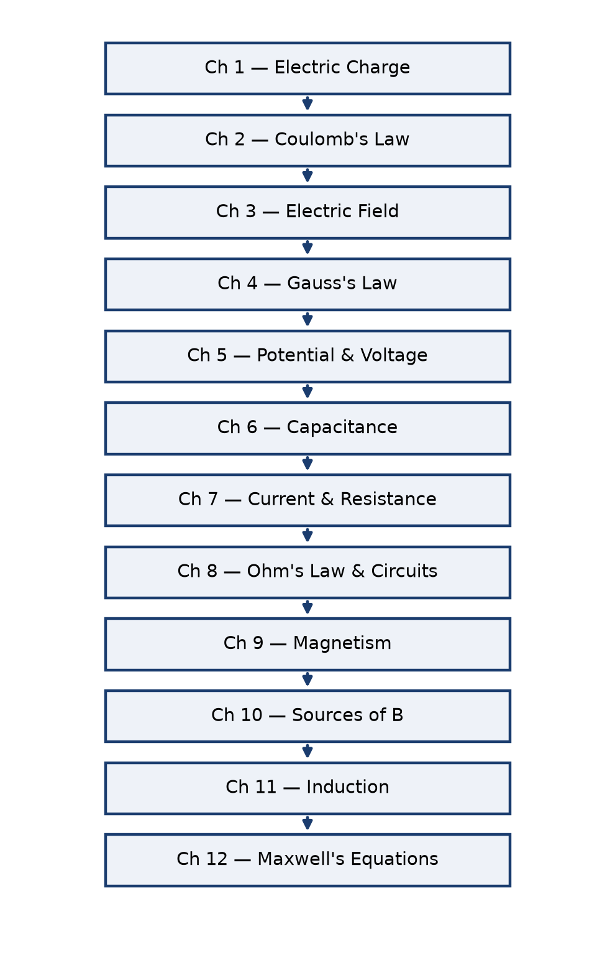

Table of Contents
Preface — How to Use This Book
About This Series
Chapter 1 — Electric Charge
Chapter 2 — Coulomb's Law and the Electric Force
Chapter 3 — The Electric Field
Chapter 4 — Electric Flux and Gauss's Law
Chapter 5 — Electric Potential Energy and Voltage
Chapter 6 — Conductors, Capacitance, and Dielectrics
Chapter 7 — Electric Current and Resistance
Chapter 8 — Ohm's Law and a First Look at Circuits
Chapter 9 — Magnetism and the Magnetic Field
Chapter 10 — Sources of the Magnetic Field
Chapter 11 — Electromagnetic Induction
Chapter 12 — Toward Maxwell's Equations and the Rest of This Series
Appendix A — Formula Reference
Appendix B — Practice Problem Solutions
Appendix C — Glossary
Appendix D — Chapter Summaries

Chapter 1 — Electric Charge

1.1 What Charge Is
Electric charge is one of a small number of properties, alongside mass, that a particle can carry without that property being made of anything more fundamental. You cannot explain charge in terms of something simpler; you can only describe what it does. What it does is this: particles with charge exert forces on other particles with charge, and those forces are enormously stronger than gravity. Two protons separated by a meter repel each other with a force about 10³⁶ times stronger than they attract each other gravitationally. Electromagnetism, not gravity, is the force that dominates chemistry, materials, and — for our purposes — every circuit ever built.
It is worth pausing on just how strange this is. Gravity is the force most people build their physical intuition around, because it is the only fundamental force whose effects are obvious in daily life without any special equipment. But gravity is, by a spectacular margin, the weakest of the four fundamental forces. The only reason gravity dominates the large-scale structure of the universe — planets, stars, galaxies — is that ordinary matter is, to very high precision, electrically neutral: the positive and negative charges in any large object nearly perfectly cancel, leaving gravity, weak as it is, as the only force with nothing to cancel it out. Get that cancellation even slightly wrong — charge a balloon by rubbing it on your hair — and the electric force wins over gravity by such a wide margin that the balloon sticks to the ceiling, plainly overpowering the gravitational pull of an entire planet.
Charge comes in two kinds, arbitrarily labeled positive and negative by Benjamin Franklin in the 1740s, before anyone knew what was actually moving inside a wire. Franklin guessed wrong about which kind of charge does the moving in metals — conventional current, the direction we still use in circuit diagrams today, points the opposite way electrons actually travel — but the labels stuck, and the sign convention is now so deeply embedded in circuit theory that no one has seriously proposed fixing it. You will get used to the fact that current “flows” one way while the electrons carrying it move the other.

1.2 The Elementary Charge and Quantization
Charge is quantized: it comes only in integer multiples of a smallest unit, the elementary charge, denoted e. Every free particle you will ever measure carries a charge that is a whole-number multiple of e (quarks are the exception, but they never appear alone outside of a nucleus, so this does not affect circuit-level physics).
e = 1.602 × 10⁻¹⁹ C
The proton carries charge +e; the electron carries charge −e. A neutral atom has equal numbers of each and so carries no net charge. When we talk about a material becoming “charged,” we mean it has acquired a surplus or deficit of electrons relative to protons — the protons themselves are locked in the nucleus and essentially never move in ordinary electrical processes.
Key Idea
Charge is conserved. The total charge in an isolated system never changes. Charge can move from one object to another, and positive and negative charge can be created or destroyed together in equal amounts (as happens in particle physics), but the net total is always constant. This single fact underlies Kirchhoff's current law, which you will meet in the circuit-theory volume of this series.

1.3 The Coulomb
The SI unit of charge is the coulomb (C), defined operationally through electric current: one coulomb is the charge transported past a point by a steady current of one ampere flowing for one second. This means the coulomb is a derived unit, defined in terms of the ampere rather than the other way around — a historical quirk that traces back to how electrical measurements were first standardized using the forces between current-carrying wires, not by counting individual charges.
A coulomb is a very large amount of charge at the scale of individual particles: it corresponds to about 6.24 × 10¹⁸ elementary charges. In practical circuits you will almost never move a full coulomb through a wire in a hurry — a typical LED might draw twenty milliamps, meaning it moves about 0.02 coulombs of charge every second. Getting a feel for this scale early pays off: when a later chapter states that a certain wire carries a current of a few amperes, you should be able to picture, at least roughly, the staggering number of individual electrons that represents moving past any given cross-section every second, even though — as Chapter 7 will make clear — none of them individually moves especially fast.

1.4 Charging by Friction, Contact, and Induction
Objects acquire net charge through several everyday mechanisms, all of which amount to moving electrons from one material to another.
- Friction (triboelectric charging): rubbing two different insulating materials together strips electrons from one surface and deposits them on the other. A balloon rubbed on hair becomes negatively charged because it pulls electrons off the hair more readily than the hair pulls them back.
- Contact charging: touching a charged conductor to a neutral one allows charge to redistribute across both until they reach a common electric potential (a concept formalized in Chapter 5).
- Charging by induction: bringing a charged object near a neutral conductor, without touching it, causes the conductor's own free electrons to redistribute — piling up on the near side if the inducing charge is positive, leaving a net positive region on the far side. Grounding the far side while the inducing charge is still present, then removing the ground and finally the inducing charge, leaves the conductor with a net charge opposite in sign to the one that induced it.
These three mechanisms look different in practice but share a single underlying idea: nothing is ever created or destroyed, only moved. It is worth checking, for each of the three, that you could point to exactly where the electrons involved came from and where they ended up — an exercise that pays dividends once Kirchhoff's current law asks you to do the same bookkeeping, far more precisely, for entire circuit networks.

1.5 Conductors and Insulators, Revisited at the Charge Level
The difference between a conductor and an insulator is entirely a difference in how tightly a material's electrons are bound. In a conductor — copper, aluminum, silver, most metals — the outermost electrons of each atom are shared collectively across the whole material rather than staying attached to individual atoms, forming what is often called a “sea” of free electrons. These electrons move readily in response to even a small electric field, which is exactly what makes a conductor useful for carrying current. In an insulator — rubber, glass, most plastics — every electron stays bound to its parent atom or molecule, and only a catastrophic field (well beyond anything found in ordinary electronics) will tear enough of them loose to allow appreciable current.
Semiconductors sit between these extremes, and the entire discipline of solid-state electronics exists because that middle ground can be controlled precisely through doping — a subject taken up in full in the semiconductor-devices volume of this series.
Common Misconception
It is tempting to think of a “fully charged” insulator as somehow saturated, unable to hold any more charge. In reality, an insulator's inability to conduct has nothing to do with how much charge it is holding — it is about whether the charge it already has is free to redistribute. A heavily charged insulating rod holds its charge in whatever pattern it was deposited in (often quite unevenly), precisely because the charge cannot move to spread out, unlike on a conductor, where excess charge always redistributes itself until it reaches electrostatic equilibrium (Chapter 6).

Practice Problems
- [Easy] A charged rod carries a charge of −8.0 nC. How many excess electrons does it carry?
- [Easy] Two identical small conducting spheres carry charges of +6.0 nC and −2.0 nC. They are touched together and separated. What charge does each sphere carry afterward?
- [Medium] Estimate how many elementary charges pass through a wire in one minute if the wire carries a steady current of 2.0 A.
- [Medium] A third identical, initially neutral sphere is touched first to a sphere carrying +9.0 nC, then separated, then touched to a different sphere carrying −3.0 nC. Find the final charge on all three spheres.
- [Easy] An object carries a charge of +3.2 × 10⁻¹⁸ C. How many elementary charges does this represent?
- [Medium] Two identical conducting spheres carry charges of −12 nC and +4.0 nC. They are touched together and separated. Find the final charge on each, and state which sphere's charge changed sign.
- [Medium] A negatively charged rod is brought near (but never touching) a neutral, grounded conducting sphere. The ground connection is removed while the rod is still nearby, and the rod is then taken away. What is the sign of the sphere's final net charge? Explain in terms of electron movement.
- [Hard] A charge of exactly 1.0 C is assembled entirely from excess electrons added to an initially neutral object. Estimate the total mass of just the added electrons (electron mass 9.11 × 10⁻³¹ kg), and comment on what this implies about whether charging an object noticeably changes its weight.
Quick-Check Answers
1. 5.0×10¹⁰ e⁻ 2. +2.0 nC each 3. ≈7.5×10²⁰ charges 4. +4.5 nC, +0.75 nC, +0.75 nC 5. 20 elementary charges 6. −4.0 nC each; sphere 2 (+4→−4 nC) flips sign, sphere 1 (−12→−4 nC) does not 7. positive 8. ≈5.7×10⁻¹² kg — negligible, confirming charging never meaningfully changes an object's weight

Chapter 2 — Coulomb's Law and the Electric Force

2.1 Stating the Law
Charles-Augustin de Coulomb established experimentally, in 1785, exactly how the force between two point charges depends on their charge and their separation, using a delicate torsion balance sensitive enough to measure forces far smaller than the weight of the charged spheres themselves. Coulomb's law states that the magnitude of the electric force between two point charges is proportional to the product of the charges and inversely proportional to the square of the distance between them:
F = k q₁q₂ / r²
where q₁ and q₂ are the magnitudes of the two charges, r is the distance between them, and k is the Coulomb constant:
k = 8.99 × 10⁹ N·m²/C²
The force is directed along the line connecting the two charges. If the charges have the same sign, the force is repulsive; if opposite, attractive. This is a vector equation in disguise — writing it as a magnitude is convenient, but you must always track direction separately, especially once more than two charges are involved.
The Coulomb constant is often written in terms of a more fundamental quantity, the permittivity of free space, ε₀:
k = 1 / (4πε₀) , ε₀ = 8.85 × 10⁻¹² C²/(N·m²)
This looks like an unnecessary complication when you are only dealing with two point charges, but the 4π factor is there so that later results — Gauss's law in particular — come out clean. You will see the payoff in Chapter 4.
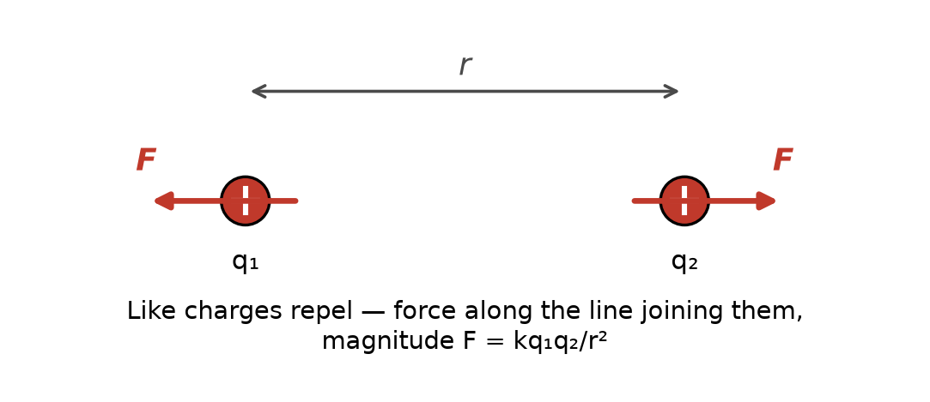
Figure 2.1 — Like charges repel along the line joining them; the force falls off as 1/r².

2.2 The Inverse-Square Behavior
The 1/r² dependence is the same functional form that governs Newton's law of gravitation, and for the same underlying geometric reason: both forces are carried by something spreading outward from a point source over the surface of an ever-expanding sphere, and the surface area of a sphere grows as r², so the intensity of anything spread evenly over that surface falls as 1/r². This geometric argument is made precise in Chapter 4 and is one of the most useful pieces of physical intuition you will carry into the rest of this series — the same 1/r² falloff will reappear when you study radiation from antennas.
Key Idea
Doubling the distance between two charges cuts the force to one quarter. Tripling the distance cuts it to one ninth. This scaling, not the specific value of k, is the fact worth internalizing.

2.3 Superposition
When more than two charges are present, the net force on any one of them is simply the vector sum of the Coulomb forces exerted by every other charge individually, as if each pair existed alone. This is the principle of superposition, and it holds because Coulomb's law is linear in each charge — nothing about the presence of a third charge alters the force law between the first two.
Superposition sounds almost too obvious to state, until you notice how much it is quietly assumed. It is not, in fact, a logical necessity — one could imagine a universe where three charges interact through some genuinely three-body force that cannot be decomposed into pairwise contributions, and such three-body effects do arise in more exotic physical settings. That electromagnetism happens not to work that way is an experimental fact, not a mathematical inevitability, and it is one of the reasons circuit analysis is tractable at all: without superposition, adding a second component to a circuit could, in principle, change how every existing component behaved with every other, rather than simply adding its own well-defined contribution.
Worked Example 2.1
Problem: Charges of +3.0 µC and +5.0 µC sit on the x-axis at x = 0 and x = 4.0 cm. Find the net force on a +2.0 µC charge placed at x = 2.0 cm.
Solution: The test charge is 2.0 cm from each source charge. The force from the +3.0 µC charge is repulsive, pushing the test charge in the +x direction: F₁ = k(3.0×10⁻⁶)(2.0×10⁻⁶)/(0.020)² ≈ 135 N. The force from the +5.0 µC charge is repulsive as well, pushing in the −x direction: F₂ = k(5.0×10⁻⁶)(2.0×10⁻⁶)/(0.020)² ≈ 225 N. These act along the same line in opposite directions, so the net force is 225 − 135 = 90 N, directed toward x = 0 (the smaller source charge is pushed away from harder, in a manner of speaking, by the larger one).
Worked Example 2.2
Problem: Three identical charges of +4.0 µC sit at the corners of an equilateral triangle with sides of 10 cm. Find the magnitude of the net force on any one of the charges.
Solution: By symmetry, the force from each of the other two charges has the same magnitude: F = kq²/r² = (8.99×10⁹)(4.0×10⁻⁶)²/(0.10)² ≈ 14.4 N. These two forces act along the two sides of the triangle meeting at the corner in question, separated by the triangle's interior angle of 60°. Adding them as vectors (using the law of cosines, or equivalently resolving into components), the net force magnitude works out to 2F cos(30°) ≈ 2(14.4)(0.866) ≈ 24.9 N, directed straight out along the triangle's line of symmetry through that corner, away from the triangle's center.

2.4 When Coulomb's Law Stops Being Enough
Coulomb's law as stated applies exactly to point charges (or equivalently, spherically symmetric charge distributions, measured from outside the sphere) that are not accelerating. Real charge distributions — a charged rod, a charged disk, the electron cloud of an atom — must be handled by dividing the distribution into infinitesimal point charges and integrating. That machinery is exactly what Gauss's law, introduced in Chapter 4, is built to avoid having to do by brute force whenever the charge distribution has enough symmetry.
Common Misconception
Students frequently write Coulomb's law with the separation r substituted as if it were always measured from a fixed origin, rather than the actual distance between the two charges in question. Once you move beyond a single pair of charges arranged conveniently on an axis, r for any given pair is always the straight-line distance between that specific pair, recomputed freshly for each pair under consideration — not a coordinate borrowed from somewhere else in the problem.

Practice Problems
- [Easy] Two point charges of +4.0 µC and −6.0 µC are separated by 30 cm. Find the magnitude and direction of the force each exerts on the other.
- [Medium] At what separation would two identical charges of +1.0 µC repel each other with a force of exactly 1.0 N?
- [Medium] Three charges lie on a line: +2.0 µC at x = 0, −3.0 µC at x = 10 cm, and +1.0 µC at x = 20 cm. Find the net force on the middle charge.
- [Hard] Two identical small spheres, each of mass 1.0 g, hang from strings of equal length attached to the same point, and repel each other so that the strings make an angle of 10° with the vertical when each sphere carries the same charge q. Set up (you need not fully solve) the equation you would use to find q, identifying every force acting on one sphere.
- [Easy] Two point charges of +2.0 µC each are placed 1.0 m apart. Find the magnitude of the force between them.
- [Medium] A fixed charge of +5.0 µC exerts a force of 0.20 N on a second charge located 15 cm away. Find the magnitude of the second charge.
- [Hard] Four identical charges of +3.0 µC sit at the corners of a square 20 cm on a side. Find the magnitude of the net force on any one of them due to the other three.
- [Hard] Two identical small spheres, each of mass 2.0 g, hang from strings 50 cm long attached to the same point. They carry equal charges and come to equilibrium 6.0 cm apart. Using the small-angle approximation, estimate the charge on each sphere.
Quick-Check Answers
1. ≈2.4 N, attractive 2. ≈9.5 cm 3. ≈2.7 N toward x = 0 4. (equation only — see Appendix B) 5. ≈0.036 N 6. ≈0.10 µC 7. ≈3.9 N, directed diagonally outward 8. ≈22 nC on each sphere

Chapter 3 — The Electric Field

3.1 Why Introduce a Field at All
Coulomb's law describes a force between two charges, but it leaves an uncomfortable question hanging: how does one charge “know” the other is there, especially across empty space, with no visible connection between them? The field concept resolves this by proposing that a charge does not reach out and grab a second charge directly. Instead, every charge alters the space around it, creating a condition — the electric field — that exists whether or not a second charge happens to be present to feel it. A second charge, placed anywhere in that altered space, simply responds to the local field at its own location.
This is more than philosophical tidiness. The field concept is what lets electromagnetism handle radiation, time delay, and energy storage in empty space — none of which fit comfortably into an “action at a distance” picture. If a source charge is suddenly moved, a distant test charge does not respond instantaneously; the change in the field propagates outward at the speed of light (Chapter 12), and until it arrives, the test charge continues to respond to where the source charge used to be. Coulomb's law alone, treated as a direct force between two charges, has no room in it for this kind of delay; the field, treated as a physically real thing occupying the space between them, does. By the time you reach the RF and antenna volumes of this series, the field will have become the primary object of study, with charges relegated to being merely its sources.

3.2 Defining the Electric Field
The electric field at a point in space is defined operationally: place a small positive “test charge” q₀ at that point, measure the force F on it, and divide by q₀.
E = F / q₀
The field is a vector, pointing in the direction of the force that would be felt by a positive test charge. Its units are newtons per coulomb (N/C), equivalently volts per meter (V/m) once potential is introduced in Chapter 5. The test charge is taken to be small enough that it does not itself disturb the charge distribution being measured — a limiting idealization, since strictly any nonzero q₀ will push the source charges around a little if they are free to move.
From Coulomb's law, the field of a single point charge q at distance r is:
E = kq / r²
directed radially outward from a positive source charge, and radially inward toward a negative one.
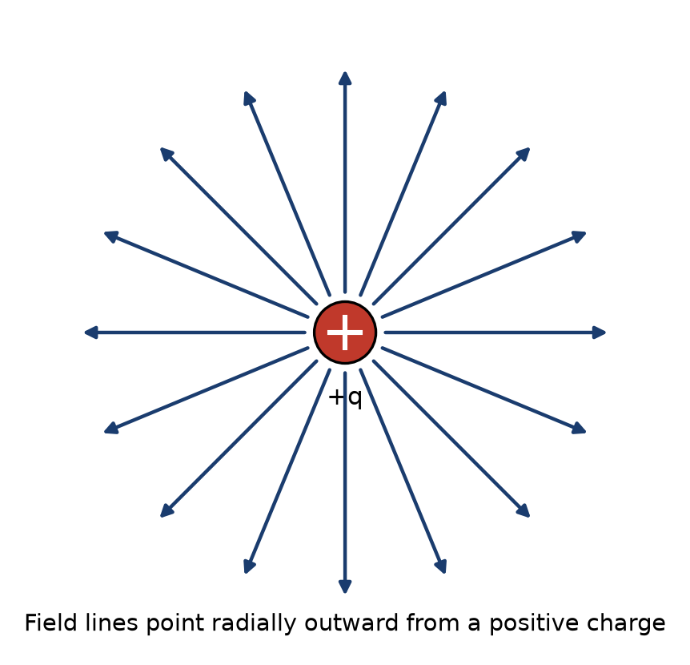
Figure 3.1 — The field of an isolated positive point charge.

3.3 Superposition of Fields
Just as forces from multiple charges add as vectors, so do the fields they produce. The net field at any point is the vector sum of the fields each source charge would produce there individually. This is the field-picture restatement of the same superposition principle from Chapter 2, and it is what makes the field concept practically useful: once you know how to add vectors, you can find the field of any charge distribution, however complicated, by summing (or integrating) the contributions of its pieces.

3.4 Field Lines
Field lines are a visualization tool, not a physical object: a diagram of curves drawn so that the tangent to the curve at any point gives the field direction there, and the density of lines (how close together they are drawn) represents field strength. Field lines originate on positive charges and terminate on negative charges (or run off to infinity if there is a net charge imbalance in the region). They never cross, because the field at any point has one and only one direction.
Key Idea
Field line density encodes field strength. Wherever field lines bunch closer together, the field is stronger; wherever they spread apart, it is weaker. This is exactly the intuition Gauss's law makes quantitative in the next chapter.

3.5 The Field of a Dipole
An electric dipole — two equal and opposite charges +q and −q separated by a small distance d — is worth working through explicitly because dipole fields reappear constantly: in molecular physics, in antenna theory, and as the building block for understanding how insulating (dielectric) materials respond to fields, which matters directly for capacitors in Chapter 6. The dipole is characterized by its dipole moment, a vector p of magnitude p = qd, pointing from the negative charge to the positive one. Far from the dipole (at distances much larger than d), the field falls off as 1/r³ rather than 1/r² — faster than a single point charge, because the +q and −q fields nearly cancel except for the small asymmetry due to their separation.
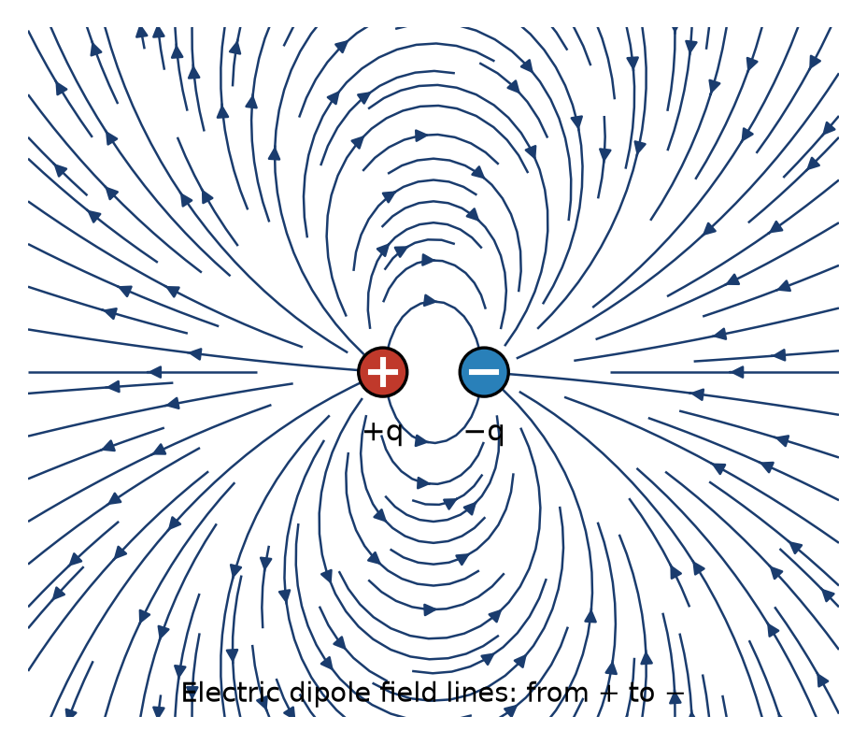
Figure 3.2 — Field lines of an electric dipole, running from the positive to the negative charge.
A dipole placed in an external, uniform electric field feels no net force (the forces on +q and −q are equal and opposite, since both charges sit in the same external field), but it does feel a net torque, which acts to rotate the dipole until p aligns with the external field. This torque-without-net-force behavior is exactly how a compass needle responds to Earth's magnetic field, and it is the mechanism by which an external field polarizes and aligns the molecular dipoles inside a dielectric material — the microscopic picture behind the macroscopic dielectric constant introduced in Chapter 6.
Worked Example 3.1
Problem: Find the electric field 5.0 cm from a point charge of +8.0 nC.
Solution: E = kq/r² = (8.99×10⁹)(8.0×10⁻⁹)/(0.050)² ≈ 2.9 × 10⁴ N/C, directed radially away from the charge.
Worked Example 3.2
Problem: A +4.0 nC charge sits at the origin and a −4.0 nC charge sits at x = 6.0 cm. Find the net electric field at the point x = 3.0 cm (the midpoint between them).
Solution: Field from the +4.0 nC charge, 3.0 cm away, points in the +x direction (away from a positive charge): E₁ = kq/r² = (8.99×10⁹)(4.0×10⁻⁹)/(0.030)² ≈ 3.996×10⁴ N/C. Field from the −4.0 nC charge, also 3.0 cm away, points in the +x direction as well (toward a negative charge, and the negative charge is further along +x, so the field at the midpoint points toward it): E₂ ≈ 3.996×10⁴ N/C, same direction. Because the two fields point the same way at the midpoint of a dipole (this is a general feature of dipole fields directly between the charges), they add rather than cancel: E_net ≈ 7.99×10⁴ N/C in the +x direction.
Common Misconception
It is a common first guess that the field exactly midway between a +q and a −q charge of equal magnitude should be zero, by some vague appeal to symmetry. The worked example above shows this is exactly backward for points between the charges: the two fields point the same direction there and add. The field actually vanishes only off to the sides, along the perpendicular bisector at exactly the right distance for the two individual field vectors to cancel — a distance that a quick sketch, not a symmetry argument alone, is needed to locate.

Practice Problems
- [Easy] Find the electric field at a point 10 cm from a −12 nC point charge.
- [Medium] Two point charges, +5.0 nC and −5.0 nC, are 4.0 cm apart. Find the field at the midpoint between them.
- [Easy] A uniform field of 500 N/C points in the +x direction. Find the force on an electron placed in this field, and state its direction.
- [Medium] A small dipole with dipole moment 2.0 × 10⁻²⁹ C·m is placed in a uniform external field of 3.0 × 10⁵ N/C, oriented perpendicular to the field. Find the magnitude of the torque on the dipole (torque on a dipole in a uniform field has magnitude τ = pE sinθ, where θ is the angle between p and E).
- [Easy] Find the electric field 20 cm from a point charge of +6.0 nC.
- [Medium] Two point charges, +8.0 nC and +8.0 nC, are placed 10 cm apart. Find the field at the midpoint between them, and explain why the result differs qualitatively from problem 2.
- [Medium] A charge of −4.0 nC experiences a force of 2.4 × 10⁻⁵ N in the +y direction at a certain point. Find the electric field (magnitude and direction) at that point.
- [Hard] Charges of +2.0 µC sit at two corners of an equilateral triangle with 15 cm sides. Find the magnitude of the net electric field at the third (empty) corner.
Quick-Check Answers
1. ≈1.08×10⁴ N/C, inward 2. ≈2.25×10⁵ N/C, from + toward − 3. 8.0×10⁻¹⁷ N, in −x 4. 6.0×10⁻²⁴ N·m 5. ≈1.35×10³ N/C, outward 6. exactly 0 — the two equal like charges' fields cancel at the midpoint, unlike the dipole case where they add 7. 6.0×10³ N/C, in −y 8. ≈1.38×10⁶ N/C, along the triangle's symmetry axis

Chapter 4 — Electric Flux and Gauss's Law

4.1 Electric Flux
Electric flux is a measure of how much electric field “flows through” a surface — the field-line-counting intuition from Chapter 3, made precise. For a flat surface of area A in a uniform field E, with the surface oriented so its normal (the perpendicular direction) makes angle θ with the field, the flux is:
Φ_{E} = E A cosθ
Flux is maximized when the field is perpendicular to the surface (θ = 0) and zero when the field runs parallel to the surface (θ = 90°), since in that case no field lines pierce through it at all. For a curved surface or a nonuniform field, this generalizes to a surface integral, E·dA integrated over the surface — but for this book's purposes, the cases that matter are the ones with enough symmetry that the integral becomes trivial, which is exactly the point of Gauss's law.

4.2 Gauss's Law
Gauss's law states that the total electric flux through any closed surface is proportional to the net charge enclosed by that surface:
Φ_{E} = Q_{enc} / ε₀
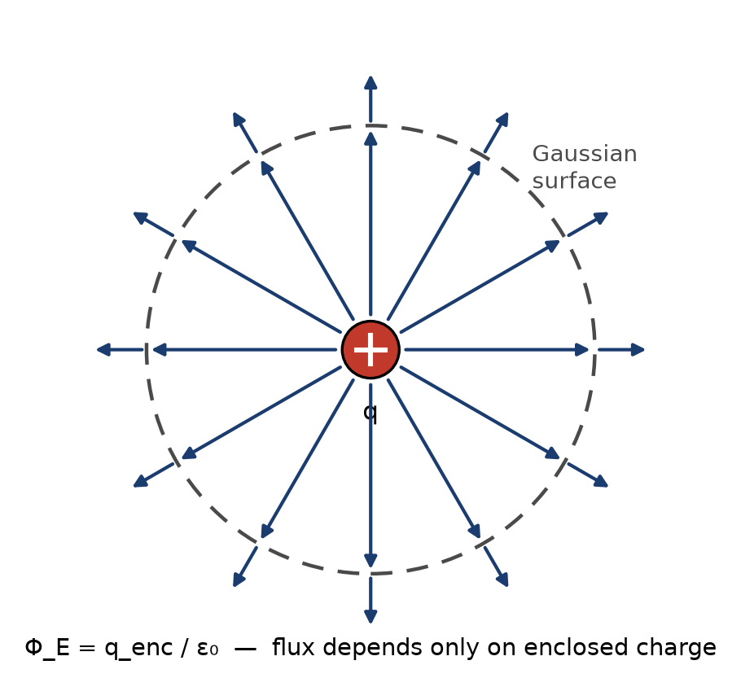
Figure 4.1 — A spherical Gaussian surface around a point charge: every field line piercing it carries the same flux, regardless of the sphere's radius.
This is one of the four Maxwell equations (met formally in Chapter 12) and it is exactly equivalent to Coulomb's law — nothing new physically is being added — but it is often dramatically easier to use. The closed surface in question, called a Gaussian surface, is entirely a mathematical construction you get to choose; it does not need to correspond to any physical boundary, and it does not need to contain any actual material at all.
Key Idea
Choose a Gaussian surface that matches the symmetry of the charge distribution. For a point charge or any spherically symmetric distribution, use a sphere. For an infinite line or cylinder of charge, use a coaxial cylinder. For an infinite sheet of charge, use a “pillbox” straddling the sheet. Get the shape right, and the field comes out of the surface integral as a constant that can be pulled outside it, turning the integral into simple algebra.

4.3 Deriving Coulomb's Law from Gauss's Law
As a consistency check, and as the cleanest illustration of the method, take a single point charge q and surround it with an imaginary sphere of radius r centered on the charge. By symmetry, the field must point radially and have the same magnitude E everywhere on the sphere's surface — there is no direction along the sphere that is special, so the field cannot depend on where on the sphere you look. The flux integral therefore reduces to E multiplied by the sphere's total surface area, 4πr²:
E (4πr²) = q / ε₀
E = q / (4πε₀r²) = kq / r²
which is exactly the point-charge field from Chapter 3 — and this is precisely why the 4π was folded into the definition of k back in Chapter 2. Choosing ε₀ that way makes Gauss's law come out with no stray factors of 4π in it, at the cost of Coulomb's law carrying that factor instead. Physicists made that trade deliberately because Gauss's law, not Coulomb's law, is the one that generalizes to Maxwell's equations.

4.4 The Field of an Infinite Charged Sheet, a Line Charge, and a Charged Conductor
Three results from this method are used constantly in circuit-adjacent physics and are worth having on hand. First, an infinite sheet of charge with uniform surface charge density σ (charge per unit area) produces a field of constant magnitude on either side, independent of distance from the sheet:
E = σ / (2ε₀)
Second, an infinite line of charge with uniform linear charge density λ (charge per unit length), found using a coaxial cylindrical Gaussian surface of radius r, produces a field:
E = λ / (2πε₀r)
falling off as 1/r rather than the 1/r² of a point source — a direct consequence of the source being an infinite line rather than a point, so that the “surface” over which the field spreads out grows only as the cylinder's circumference (proportional to r), not as a sphere's full surface area (proportional to r²).
Third — and this result underlies why charge sits on the outer surface of a conductor and why the interior of a conductor in electrostatic equilibrium has exactly zero field — a Gaussian surface drawn entirely inside a conducting material, where charge is free to move, must enclose zero net charge, because if there were any field inside the conductor, its free electrons would still be accelerating, contradicting the assumption of equilibrium. All excess charge on a charged conductor therefore resides entirely on its outer surface, a fact this book will use again in Chapter 6 when introducing capacitors.
Worked Example 4.1
Problem: A solid conducting sphere carries a total charge of +6.0 µC. Find the electric field at a point 20 cm from the center, given the sphere's radius is 5.0 cm.
Solution: Since 20 cm is outside the sphere, and the sphere is spherically symmetric, Gauss's law gives exactly the point-charge result with all the charge treated as concentrated at the center: E = kq/r² = (8.99×10⁹)(6.0×10⁻⁶)/(0.20)² ≈ 1.35 × 10⁶ N/C. Note that the field outside a uniformly charged sphere is identical to that of a point charge of the same total charge — the sphere's actual radius plays no role once you are outside it.
Worked Example 4.2
Problem: An infinite sheet carries a uniform surface charge density of +2.0 µC/m². Find the field 1.0 cm and 10 cm from the sheet, and comment on what you find.
Solution: E = σ/(2ε₀) = (2.0×10⁻⁶)/[2(8.85×10⁻¹²)] ≈ 1.13 × 10⁵ N/C — at both distances, since the field of an ideal infinite sheet does not depend on distance from the sheet at all. This is a genuinely surprising result on first encounter (compare it against the point-charge and line-charge results, which both fall off with distance), and it follows directly from the field-line picture in Chapter 3: for a truly infinite sheet, the field lines run straight out perpendicular to the sheet and never spread apart, so their density — and hence the field strength — never decreases with distance. Real, finite sheets only approximate this behavior close to the sheet, well away from its edges.
Common Misconception
The infinite-sheet result E = σ/(2ε₀) is sometimes misapplied to a conductor's surface, where the correct result is instead E = σ/ε₀ — twice as large, with no factor of 2 in the denominator. The difference is not an error in either formula; it reflects a genuinely different physical situation. An isolated charged sheet (with vacuum or a symmetric environment on both sides) splits its flux evenly, half going each way, which is where the factor of 2 in the sheet result comes from. A conductor's outer surface, by contrast, has zero field on its interior side (Chapter 6) by definition of electrostatic equilibrium, so all of the flux is forced out through the exterior side alone, doubling the field there relative to the two-sided sheet case for the same σ.

Practice Problems
- [Easy] A Gaussian sphere of radius 3.0 cm encloses a net charge of +2.0 nC. What is the total electric flux through the sphere?
- [Medium] An infinite sheet carries a uniform surface charge density of +4.0 µC/m². Find the field 2.0 cm from the sheet.
- [Medium] Explain, using Gauss's law, why the electric field just outside the surface of a charged conductor is always perpendicular to that surface.
- [Medium] An infinitely long straight wire carries a uniform linear charge density of +5.0 nC/m. Find the electric field at a perpendicular distance of 4.0 cm from the wire.
- [Easy] A Gaussian cube of side 10 cm encloses a net charge of −5.0 nC. Find the total electric flux through the cube, and explain why the cube's shape and size do not enter the calculation.
- [Medium] A spherical Gaussian surface of radius 5.0 cm, centered on a point charge, measures a total outward flux of 3.39 × 10³ N·m²/C. Find the enclosed charge.
- [Medium] Two infinite parallel sheets carry surface charge densities of +3.0 µC/m² and −3.0 µC/m². Find the electric field in the region between the sheets and in the regions outside both sheets.
- [Hard] A solid non-conducting sphere of radius R carries charge Q spread uniformly through its volume. Using a spherical Gaussian surface of radius r < R, show that the field inside the sphere is E = kQr/R³, and evaluate it at r = R/2.
Quick-Check Answers
1. ≈226 N·m²/C 2. ≈2.26×10⁵ N/C 3. (conceptual — see Appendix B) 4. ≈2.25×10³ N/C 5. ≈−565 N·m²/C; shape/size never enters Gauss's law, only enclosed charge 6. 30 nC 7. Between the sheets: ≈3.39×10⁵ N/C; outside either sheet: 0 8. E(R/2) = kQ/(2R²)

Chapter 5 — Electric Potential Energy and Voltage

5.1 From Force to Energy
Every conservative force has an associated potential energy, and the electric force is conservative — the work done moving a charge between two points does not depend on the path taken, only on the endpoints. This mirrors gravitational potential energy exactly, and the analogy is worth leaning on: just as an object gains gravitational potential energy when lifted against gravity, a positive charge gains electric potential energy when pushed toward another positive charge, against the repulsive force between them.
For two point charges q and Q separated by distance r, the electric potential energy of the pair is:
U = kqQ / r
Notice the missing square on r, compared to Coulomb's law's force expression — potential energy for a 1/r² force always goes as 1/r, the same relationship gravitational potential energy (U = −GMm/r) has to gravitational force. U is positive for like charges (energy is stored by pushing them together, against their mutual repulsion) and negative for unlike charges (energy is released by pulling them apart, against their mutual attraction).

5.2 Electric Potential (Voltage)
Just as the electric field is the force per unit charge, electric potential is the potential energy per unit charge:
V = U / q₀
Potential is a scalar, not a vector — a considerable practical simplification over working with fields directly, since scalars just add algebraically with no direction bookkeeping. Its SI unit is the volt (V), equal to one joule per coulomb, and it is this quantity — not the field, and not the potential energy — that a voltmeter measures and that appears on every component datasheet and circuit diagram you will encounter for the rest of this series.
The potential due to a single point charge q, at distance r, taking the zero of potential to be at infinity (the conventional choice), is:
V = kq / r
Key Idea
Only differences in potential are ever physically meaningful. The choice of where V = 0 is a convention, not a physical fact — exactly like choosing sea level as the zero of height. What every circuit actually cares about is potential difference, the voltage between two points, which is why circuit diagrams always show voltage across a component, never a component's voltage in some absolute sense.

5.3 Relating Potential and Field
Potential and field are two descriptions of the same underlying physics, related by the fact that the field points in the direction potential decreases most steeply, and its magnitude is the rate of that decrease. In one dimension:
E = −dV/dx
For the simplest and most important practical case — a uniform field between two parallel plates separated by distance d, with potential difference ΔV between them — this reduces to:
E = ΔV / d
This equation is the workhorse relation for parallel-plate capacitors, taken up in the next chapter, and it is also the reason the field's units, newtons per coulomb, are numerically identical to volts per meter — both are legitimate units for E, and V/m is the one you will see far more often in practice.

5.4 Equipotential Surfaces
An equipotential surface is a surface on which every point has the same potential. Because moving a charge along an equipotential requires no work (there is no change in potential energy), electric field lines must always cross equipotential surfaces at right angles — if a field had any component along an equipotential surface, moving a charge along that direction would change its potential energy at constant potential, a contradiction. For a point charge, the equipotentials are concentric spheres; for a uniform field, they are flat planes perpendicular to the field.
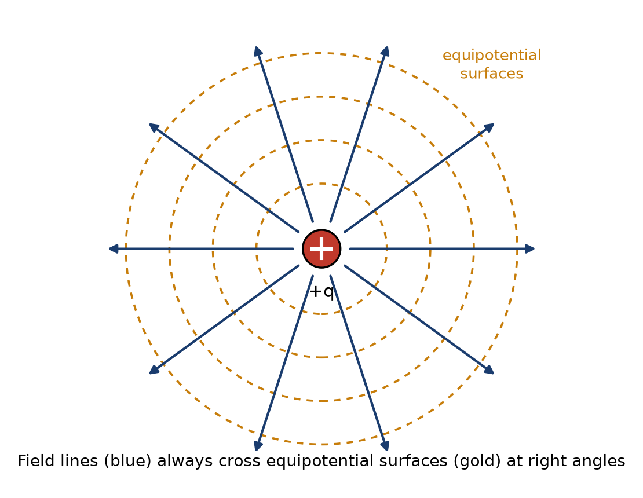
Figure 5.1 — Equipotential surfaces (gold, dashed) around a point charge, always perpendicular to the field lines (blue).
This right-angle relationship is a genuinely useful sketching tool: given a diagram of field lines for some charge distribution, you can sketch a reasonable set of equipotential contours simply by drawing curves everywhere perpendicular to the field lines you already have, and vice versa. Topographic maps use exactly this relationship, incidentally, with contour lines of constant elevation (the gravitational analogue of equipotentials) always running perpendicular to the direction water would actually flow downhill.

5.5 Energy Stored in the Electric Field
It is natural, and correct, to think of the potential energy U = kqQ/r as belonging jointly to the pair of charges, rather than to either charge individually — after all, U depends on both charges and vanishes if either one is removed. A more modern and, for this series' purposes, more useful way to think about that same energy is that it is stored in the electric field occupying the space around the charges, at an energy density (energy per unit volume) proportional to E². This field-centered accounting becomes indispensable once fields exist without any nearby charge to “belong” to — as in an electromagnetic wave, where energy propagates through empty space with no charges present at all. Chapter 6 develops the field-energy picture concretely for the case of a capacitor, where it becomes possible to compute a definite, measurable quantity: the total energy stored between two charged plates.
Worked Example 5.1
Problem: Two parallel plates 2.0 mm apart are held at a potential difference of 100 V. Find the electric field between them, and the potential energy change of an electron moved from the negative plate to the positive plate.
Solution: The field magnitude is E = ΔV/d = 100 V / 0.0020 m = 5.0 × 10⁴ V/m. Moving an electron (charge −e) from the negative plate to the positive plate means moving it against the field's push on a positive charge — but the electron is negative, so the field actually assists this motion, and the electron's potential energy decreases. Numerically, ΔU = qΔV = (−1.60×10⁻¹⁹ C)(100 V) = −1.60×10⁻¹⁷ J: the electron loses 1.60×10⁻¹⁷ J of potential energy, which reappears as kinetic energy — exactly the mechanism that accelerates electrons in a cathode-ray tube or a particle accelerator.
Worked Example 5.2
Problem: Find the electric potential at a point midway between a +6.0 nC charge and a −6.0 nC charge, separated by 8.0 cm.
Solution: Potential is a scalar, so it adds algebraically (no vectors needed) — a considerable simplification compared to the equivalent field calculation. Each charge is 4.0 cm from the midpoint. V₁ = kq/r = (8.99×10⁹)(6.0×10⁻⁹)/(0.040) ≈ 1348 V (from the positive charge). V₂ = kq/r = (8.99×10⁹)(−6.0×10⁻⁹)/(0.040) ≈ −1348 V (from the negative charge). Net potential: V₁ + V₂ = 0 V. Contrast this with Worked Example 3.2, which found a nonzero field at the same midpoint of an equal-and-opposite dipole — potential and field do not have to vanish (or fail to vanish) at the same locations, since one is a scalar sum and the other a vector sum, and this particular symmetric case happens to make the potential exactly zero everywhere on the entire perpendicular bisector plane, not just at the midpoint.

Practice Problems
- [Easy] Find the electric potential 15 cm from a point charge of +3.0 nC.
- [Medium] How much work is required to bring a +2.0 nC charge from infinity to a point 10 cm from a fixed +5.0 nC charge?
- [Easy] A uniform field of 2.0 × 10⁴ V/m exists between two plates 5.0 mm apart. Find the potential difference between the plates.
- [Medium] An electron is accelerated from rest through a potential difference of 500 V. Find its final kinetic energy in joules, and its final speed (electron mass 9.11×10⁻³¹ kg).
- [Easy] Find the electric potential 20 cm from a point charge of −4.0 nC.
- [Medium] Two +4.0 nC charges are placed 12 cm apart. Find the electric potential at the midpoint between them, and compare with the field found there.
- [Medium] How much work is required to move a −3.0 nC charge from a point where the potential is +200 V to a point where the potential is −100 V?
- [Hard] Three point charges of +2.0 nC each sit at the corners of an equilateral triangle with 10 cm sides. Find the total electric potential energy of the configuration.
Quick-Check Answers
1. ≈180 V 2. ≈8.99×10⁻⁷ J 3. 100 V 4. KE ≈8.0×10⁻¹⁷ J, v ≈1.33×10⁷ m/s 5. ≈−180 V 6. ≈1.2×10³ V (nonzero, unlike the equal-and-opposite dipole case) 7. ≈+900 nJ (work must be supplied) 8. ≈1.08 µJ

Chapter 6 — Conductors, Capacitance, and Dielectrics

6.1 Conductors in Electrostatic Equilibrium
Chapter 4 established that a conductor in electrostatic equilibrium has zero field inside it and all excess charge on its outer surface. Two further facts follow directly and are used constantly in circuit reasoning: the entire volume of a conductor in equilibrium is at a single, uniform potential (since E = 0 inside means V cannot change from point to point within it), and its surface is therefore an equipotential surface. This is precisely why we can speak of “the potential of a wire” or “the potential of a plate” as a single number, without needing to specify which point on that conductor we mean.

6.2 Capacitance Defined
Any two conductors separated by an insulator (or vacuum) form a capacitor: place equal and opposite charges +Q and −Q on the two conductors, and a potential difference V develops between them. Capacitance is defined as the ratio of charge to voltage:
C = Q / V
Capacitance is a purely geometric property of a given pair of conductors — it depends on their shape, size, separation, and the material between them, but not on Q or V individually, since doubling Q doubles V proportionally, leaving the ratio fixed. Its SI unit is the farad (F), equal to one coulomb per volt; a farad is an enormous unit for practical components, so real capacitors are almost always specified in microfarads (µF, 10⁻⁶ F), nanofarads (nF, 10⁻⁹ F), or picofarads (pF, 10⁻¹² F).

6.3 The Parallel-Plate Capacitor
The parallel-plate capacitor is the simplest and most instructive geometry, and its capacitance can be derived directly from the tools already built in this book. Two plates of area A, separated by distance d, carry charges +Q and −Q with surface charge density σ = Q/A on each. From Chapter 4, each charged sheet produces a field σ/(2ε₀) on either side; between the two plates, these fields add (they point the same direction there), while outside the plates they cancel. The field between the plates is therefore:
E = σ / ε₀ = Q / (ε₀A)
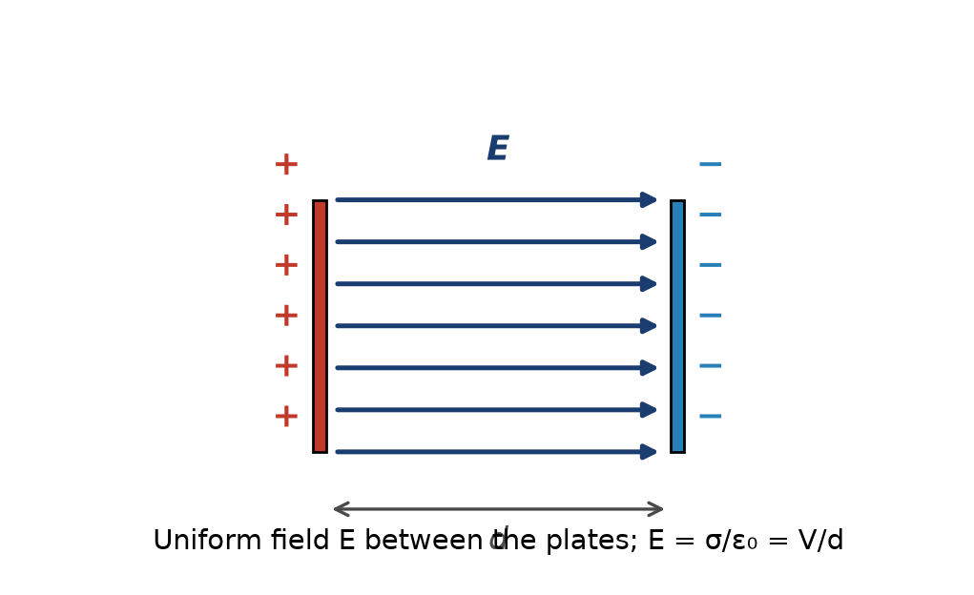
Figure 6.1 — A parallel-plate capacitor: uniform field between the plates, pointing from + to −.
Combining this with V = Ed from Chapter 5 and C = Q/V gives:
C = ε₀ A / d
Capacitance increases with plate area (more room to store charge at a given field) and decreases with plate separation (a smaller gap produces a larger field, hence a larger voltage, for the same charge — so it takes less charge to reach a given voltage, meaning C = Q/V actually increases as d shrinks; check the algebra above to confirm this rather than trusting intuition alone, since the direction of this dependence trips up many students on a first pass).

6.4 Dielectrics
Filling the gap between the plates with an insulating material — a dielectric — rather than vacuum increases the capacitance by a factor κ, the dielectric constant (also called relative permittivity), a dimensionless number greater than 1 that depends on the material (roughly 1 for air, about 4–7 for common glass, and well over 1000 for some specialized ceramics used in high-value capacitors):
C = κ ε₀ A / d
The physical mechanism is polarization: the dielectric's own molecules, whether permanently polar or only polarized in response to the applied field, align themselves so that their own small dipole fields (Chapter 3) partially cancel the applied field inside the material. A weaker net field for the same free charge Q means a smaller voltage V = Ed, and since C = Q/V, a smaller V at fixed Q means a larger C. Dielectrics also raise the voltage at which the capacitor breaks down (arcs across), which is often as important in practical component selection as the capacitance value itself, and this maximum safe voltage is called the component's dielectric strength or working voltage.

6.5 Capacitors in Series and Parallel
Just as resistors combine in series and parallel (Chapter 8), so do capacitors, but — reflecting how capacitance is a fundamentally different kind of quantity from resistance — the combination rules come out reversed relative to resistors. Capacitors in parallel (both connected across the same pair of nodes, so both see the same voltage) simply add:
C_{parallel} = C₁ + C₂ + …
which makes sense physically: connecting capacitors in parallel is equivalent to increasing the effective plate area, and capacitance from Section 6.3 scales directly with area. Capacitors in series (connected end to end, so each carries the same charge Q, with the voltages across each adding to the total) combine by the reciprocal-sum rule instead:
1/C_{series} = 1/C₁ + 1/C₂ + …
which is the same functional form parallel resistors use, not series resistors — a fact worth committing to memory precisely because it is so easy to reach for the wrong rule by pattern-matching on the word “series” alone.
Key Idea
A capacitor stores energy, not just charge. The energy stored is U = ½CV² = ½QV = Q²/(2C). This stored energy is genuinely present in the electric field occupying the space between the plates — not a bookkeeping convenience — a fact that becomes important once you study energy flow in electromagnetic fields more generally.
Worked Example 6.1
Problem: A parallel-plate capacitor has plates of area 2.0 cm² separated by 0.10 mm of air. Find its capacitance, and the capacitance if the gap is instead filled with a dielectric of κ = 5.0.
Solution: Area in SI units: A = 2.0×10⁻⁴ m², d = 1.0×10⁻⁴ m. Air-filled: C = ε₀A/d = (8.85×10⁻¹²)(2.0×10⁻⁴)/(1.0×10⁻⁴) ≈ 17.7 pF. With the dielectric: C = κ × 17.7 pF = 88.5 pF — a fivefold increase, exactly matching κ.
Worked Example 6.2
Problem: A 6.0 µF capacitor and a 3.0 µF capacitor are connected (a) in parallel and (b) in series. Find the equivalent capacitance in each case.
Solution: (a) Parallel: C = 6.0 + 3.0 = 9.0 µF — larger than either individual value, as parallel capacitance always is. (b) Series: 1/C = 1/6.0 + 1/3.0 = 1/6.0 + 2/6.0 = 3/6.0, so C = 2.0 µF — smaller than either individual value, as series capacitance always is. Notice this is exactly the opposite pattern from resistors, where series combinations are always larger and parallel combinations are always smaller than any individual value.
Common Misconception
Because capacitors and resistors are both drawn the same way in a circuit diagram — components in a line are “in series,” components bridging the same two nodes are “in parallel” — it is a very natural mistake to apply the resistor combination formulas to capacitors by habit. Resistance and capacitance are related to voltage and charge in inverted ways (R = V/I versus C = Q/V), which is exactly why their series and parallel rules come out swapped relative to each other. When in doubt, rederive the rule from first principles — same charge for series capacitors, same voltage for parallel ones — rather than trusting memorized pattern-matching alone.

Practice Problems
- [Easy] A capacitor has capacitance 4.0 µF and is charged to 12 V. Find the charge stored and the energy stored.
- [Medium] A parallel-plate capacitor's plate separation is doubled while the charge on it is held fixed. What happens to its capacitance, its voltage, and its stored energy?
- [Easy] A 10 pF capacitor is filled with a dielectric of κ = 3.5. Find the new capacitance.
- [Medium] Three capacitors, 2.0 µF, 4.0 µF, and 4.0 µF, are all connected in parallel across a 9.0 V source. Find the total charge supplied by the source.
- [Easy] A 2.0 µF capacitor is charged to 50 V. Find the charge and energy stored.
- [Medium] A 20 pF air-gap capacitor remains connected to a battery holding its voltage fixed while a dielectric of κ = 6.0 is inserted. Find the new capacitance, and state how the stored charge changes.
- [Medium] A 3.0 µF and a 6.0 µF capacitor are connected in series across a 12 V source. Find the equivalent capacitance, the charge on each capacitor, and the voltage across each.
- [Hard] A parallel-plate capacitor (plate area 4.0 cm², separation 0.20 mm) is charged by a 6.0 V battery, then disconnected from the battery before its separation is doubled to 0.40 mm. Find the capacitance and stored energy before and after, and explain in physical terms where the change in energy comes from.
Quick-Check Answers
1. Q = 48 µC, U ≈ 2.88×10⁻⁴ J 2. C halves, V doubles, U doubles 3. 35 pF 4. Q_total = 90 µC 5. Q = 100 µC, U = 2.5 mJ 6. C = 120 pF; Q increases sixfold, since the battery holds V fixed 7. C_eq = 2.0 µF; Q = 24 µC on each; V₁ = 8.0 V, V₂ = 4.0 V 8. C: 17.7 pF → 8.85 pF (charge fixed at ≈106 pC); U: ≈3.19×10⁻¹⁰ J → ≈6.37×10⁻¹⁰ J, doubling — the extra energy is supplied by the mechanical work done pulling the attracting plates apart

Chapter 7 — Electric Current and Resistance

7.1 Current Defined
Everything so far in this book has concerned static charge — charge sitting still. Current is what happens when charge moves in an organized way. Electric current is defined as the rate at which charge passes a given cross-section of a conductor:
I = dQ/dt
with SI unit the ampere (A), equal to one coulomb per second. By long-standing convention (traceable to Franklin's original, backwards guess mentioned in Chapter 1), current is defined as flowing in the direction positive charge would move — which in an ordinary metal wire is opposite to the actual direction the (negatively charged) conduction electrons travel. This convention is used universally in circuit diagrams and will be used throughout the rest of this series without further comment.

7.2 Current Density and Drift Velocity
It is worth being honest about how slowly electrons in a wire actually move, because the result is famously counterintuitive. Current density J is current per unit cross-sectional area, J = I/A, and it is related to the drift velocity vᴅ of the charge carriers (the average velocity they acquire in the direction opposing the field, superimposed on their much larger random thermal motion) by:
J = n q v_{d}
where n is the number density of charge carriers and q is the carrier's charge. For a typical copper wire carrying a modest current, the drift velocity works out to a small fraction of a millimeter per second — an electron takes minutes to physically travel the length of a household wire. What makes a lamp turn on essentially instantly when you flip a switch is not any individual electron racing to the bulb; it is that the electric field itself, and the resulting nudge to every electron already present throughout the wire, propagates at a substantial fraction of the speed of light. The signal is fast; the carriers themselves are almost leisurely.
This distinction between the speed of the signal and the speed of the individual carriers is worth sitting with, because it resolves what otherwise looks like a genuine paradox: a wire a few kilometers long, carrying a current whose individual electrons drift at a fraction of a millimeter per second, will still light a bulb at its far end within a small fraction of a second of the switch closing. Nothing in that observation requires any electron to travel the wire's length quickly — only the field's influence, already present all along the wire, needs to propagate, and that is a wave phenomenon governed by the electromagnetic-wave result of Chapter 12, not by how fast any individual charge carrier happens to be moving.
Worked Example 7.0 — How Slow Is Drift Velocity, Really?
Problem: A copper wire of cross-sectional area 2.0 mm² carries a steady current of 5.0 A. Copper has roughly 8.5 × 10²⁸ free electrons per cubic meter. Estimate the drift velocity of the conduction electrons.
Solution: From J = nqv_d, solve for v_d: v_d = J/(nq) = I/(nqA). Plugging in: v_d = (5.0) / [(8.5×10²⁸)(1.60×10⁻¹⁹)(2.0×10⁻⁶)] ≈ 1.8 × 10⁻⁴ m/s — about 0.18 mm per second. At this rate, an individual electron would take roughly 95 minutes to travel just one meter of wire. Every appliance in your home nonetheless responds within a fraction of a second of being switched on, which is only possible because — as this section emphasizes — it is the field's influence propagating through the wire, not the individual electrons' own leisurely progress, that actually carries the “signal.”

7.3 Resistance and Resistivity
Most materials resist the flow of current to some degree, converting electrical energy into heat as charge carriers collide with the material's atomic lattice. For a given conductor, resistance R is defined by how much voltage is required to drive a given current through it, and for many materials over a wide range of conditions, R is very nearly constant — this is Ohm's law, the subject of Chapter 8.
Resistance depends on the conductor's geometry and on an intrinsic material property, resistivity ρ:
R = ρ L / A
where L is the conductor's length and A is its cross-sectional area. Resistance increases with length (more material for carriers to push through) and decreases with cross-sectional area (more parallel paths available). Resistivity is a property of the material alone, independent of shape — copper's resistivity is famously low, which along with its low cost and easy workability is exactly why it dominates wiring; the same reasoning drives the choice of exotic low-resistivity materials like silver in specialized high-frequency applications discussed later in this series.
Conductivity: σ = 1/ρ (units: siemens per meter, S/m)

7.4 Temperature Dependence
Resistivity is temperature dependent, and for most metals it increases with temperature: hotter atoms vibrate more vigorously, scattering conduction electrons more frequently and impeding their drift. Over a modest temperature range, this is well approximated as linear:
ρ(T) ≈ ρ₀ [1 + α(T − T₀)]
where α is the temperature coefficient of resistivity, positive for metals. Semiconductors behave oppositely — their resistivity generally decreases with rising temperature, because additional thermal energy frees more charge carriers to conduct, an effect that dominates over increased scattering. This opposite-sign behavior is one of the first clues, historically, that semiconductors work by a fundamentally different mechanism than metals, a subject developed fully in the semiconductor-physics volume of this series.

7.5 Superconductivity, Briefly
A small number of materials, cooled below a characteristic critical temperature (for many common superconductors, only a few degrees above absolute zero, though so-called high-temperature superconductors reach tens of degrees above it), undergo a genuinely abrupt transition to a state of exactly zero resistivity — not merely very low resistivity, but immeasurably, and as far as any experiment has ever detected, exactly zero. A current started in a closed superconducting loop has been observed to persist, undiminished, for years without any external source maintaining it. Superconductivity is a quantum-mechanical phenomenon well beyond this book's scope to explain properly, but it is worth knowing it exists: it demonstrates that the ordinary, temperature-dependent resistivity described above is not some unavoidable law of nature, but a specific consequence of how electrons scatter off a lattice's vibrations and impurities in ordinary conducting materials — a mechanism that a superconductor, below its critical temperature, simply does not have.
Worked Example 7.1
Problem: A copper wire (ρ = 1.68 × 10⁻⁸ Ω·m) is 2.0 m long with a cross-sectional area of 1.0 mm². Find its resistance.
Solution: R = ρL/A = (1.68×10⁻⁸ Ω·m)(2.0 m) / (1.0×10⁻⁶ m²) = 0.0336 Ω — a small resistance, typical of why short lengths of ordinary hookup wire are treated as essentially resistance-free in introductory circuit problems.
Worked Example 7.2
Problem: A nichrome heating element (used, for example, in a toaster) has a resistivity of 1.10 × 10⁻⁶ Ω·m. Find the length of nichrome wire, with a cross-sectional area of 0.20 mm², needed to make a resistance of 20 Ω, and compare this to the copper wire in the previous example.
Solution: Rearranging R = ρL/A for length: L = RA/ρ = (20)(0.20×10⁻⁶)/(1.10×10⁻⁶) ≈ 3.6 m. Nichrome's resistivity is roughly 65 times larger than copper's, which is exactly why it is chosen for heating elements rather than copper: a practical, compact length of wire can be made to have substantial resistance (and therefore, by the power relations of Chapter 8, to dissipate substantial heat) without needing an impractically long or thin wire the way copper would require for the same resistance.
Common Misconception
It is easy to conflate resistance and resistivity, since both describe a material “resisting” current in some loose sense, and to therefore treat resistivity as if it changed when a wire is cut shorter or drawn thinner. Resistivity is a fixed property of the material itself, at a given temperature — cutting a copper wire in half does not change copper's resistivity at all, though it does change that particular piece of wire's resistance, because resistance depends on geometry (R = ρL/A) while resistivity does not.

Practice Problems
- [Easy] A wire carries a current of 3.0 A. How much charge passes a given point in the wire in 5.0 seconds?
- [Medium] A conductor's length is tripled while its cross-sectional area is halved. By what factor does its resistance change?
- [Medium] A resistor has resistance 100 Ω at 20°C and a temperature coefficient of resistivity of 0.004 /°C. Estimate its resistance at 80°C.
- [Medium] A copper wire and an aluminum wire (resistivity 2.65 × 10⁻⁸ Ω·m) have the same length and the same resistance. Find the ratio of their cross-sectional areas.
- [Easy] A current of 2.5 A flows through a wire for 2.0 minutes. Find the total charge that passes.
- [Medium] A wire's cross-sectional area is doubled while it carries the same current as before. What happens to its current density J and its drift velocity v_d?
- [Medium] A silver wire (resistivity 1.59 × 10⁻⁸ Ω·m) and a copper wire (1.68 × 10⁻⁸ Ω·m) have the same cross-sectional area and the same resistance. Find the ratio of their lengths, L_Ag/L_Cu.
- [Hard] A tungsten filament has resistance 10 Ω at 20°C and a temperature coefficient of resistivity of 0.0045/°C. Estimate its resistance once it heats up to a typical operating temperature of 2500°C, and use the result to explain why an incandescent bulb draws a large “inrush” current at the instant it is switched on.
Quick-Check Answers
1. 15 C 2. ×6 3. 124 Ω 4. A_Cu/A_Al ≈ 0.634 5. 300 C 6. Both J and v_d are cut in half 7. L_Ag/L_Cu ≈ 1.057 — silver can be about 5.7% longer for the same resistance 8. R ≈ 122 Ω when hot, roughly 12× its cold value, so at the instant of switch-on the filament is still cold and low-resistance, drawing far more current than it does once it heats up and settles to its steady operating resistance

Chapter 8 — Ohm's Law and a First Look at Circuits

8.1 Ohm's Law
Georg Ohm found, in 1827, that for a large class of materials (now called ohmic materials, or resistors when packaged as discrete components), the current through the material is directly proportional to the voltage across it, at a fixed temperature:
V = IR
This is not a law of nature in the way Coulomb's law or Gauss's law are — it is an empirical approximation that happens to hold extremely well for metals and for manufactured resistors under normal operating conditions, and it fails outright for many devices you will meet later in this series, including diodes and transistors, whose entire usefulness stems from their current-voltage relationship being deliberately non-Ohmic.
Key Idea
Ohm's law relates three quantities — memorize the triangle, not just the formula. V = IR, so also I = V/R and R = V/I. Given any two of voltage, current, and resistance, the third follows immediately. This single relationship, together with the two Kirchhoff laws developed in the dedicated circuit-theory volume of this series, is sufficient to analyze any resistive DC circuit, no matter how complex.

8.2 Power in a Resistor
Electrical power is the rate at which electrical energy is delivered or dissipated:
P = IV
Combined with Ohm's law, this yields two equally useful alternate forms:
P = I²R = V²/R
For a resistor, this power is dissipated as heat — this is Joule heating, the same physical mechanism (electrons scattering off the lattice, from Chapter 7) that gives rise to resistance in the first place, now viewed from an energy-accounting perspective rather than a current-impeding one. Every resistor in a real circuit has a maximum power rating, beyond which the resulting heat will damage or destroy it; checking that a resistor's power rating exceeds its expected dissipation is a standard, mandatory step in circuit design that this series will return to repeatedly.

8.3 A First Circuit: Series and Parallel Resistors
Two resistors are in series if the same current must flow through both, one after the other, with no branch point between them. Their combined resistance simply adds:
R_{series} = R₁ + R₂ + …
Two resistors are in parallel if both are connected across the same pair of nodes, so the same voltage appears across each while the total current splits between them. Their combined resistance follows from the reciprocal sum:
1/R_{parallel} = 1/R₁ + 1/R₂ + …
A useful special case, worth having memorized, is two resistors in parallel:
R_{parallel} = R₁R₂ / (R₁ + R₂)
Series resistance is always larger than the largest individual resistor (more obstacles, end to end); parallel resistance is always smaller than the smallest individual resistor (more parallel paths for current to take, so less overall opposition). This behavior — and the systematic method for analyzing arbitrary networks that do not reduce to simple series/parallel combinations — is developed in full in this series' dedicated circuit-theory volume, which builds directly on the definitions in this chapter.
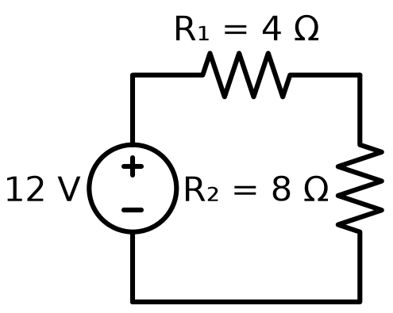
Figure 8.1 — Two resistors in series across a source: the same current flows through both.

8.4 A First Look at Voltage Division
One immediate, practical consequence of the series-resistor rule is worth introducing here, ahead of its full treatment in the circuit-theory volume, because it appears so often in practice: two resistors in series across a voltage source V split that voltage between them in direct proportion to their resistances, since the same current I flows through both:
V₁ = V · R₁ / (R₁ + R₂) , V₂ = V · R₂ / (R₁ + R₂)
This voltage divider is one of the single most common sub-circuits in all of electronics, used to derive a smaller reference voltage from a larger supply, and it is worth internalizing this chapter's result now, since it will reappear as a building block almost immediately in the next book of this series.
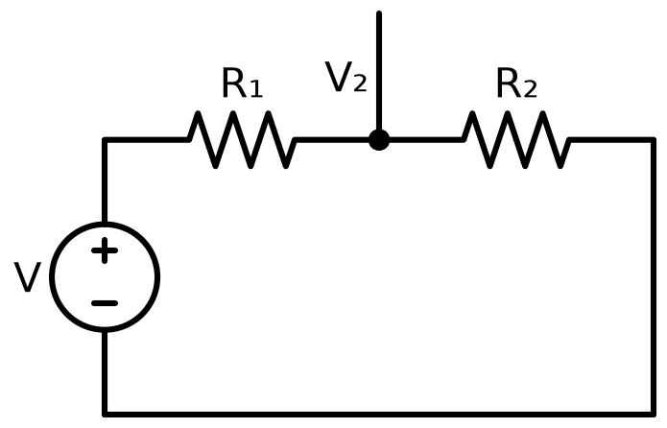
Figure 8.2 — A voltage divider: the tap point between R₁ and R₂ delivers a fixed fraction of the source voltage.
Worked Example 8.1
Problem: A 12 V battery is connected across a single 6.0 Ω resistor. Find the current drawn and the power dissipated.
Solution: I = V/R = 12/6.0 = 2.0 A. Power: P = IV = (2.0)(12) = 24 W (equivalently P = I²R = (2.0)²(6.0) = 24 W, a useful cross-check).
Worked Example 8.2
Problem: A 10 Ω resistor and a 30 Ω resistor are connected in series across a 20 V source. Find the current through the circuit and the voltage across each resistor.
Solution: Total series resistance: R = 10 + 30 = 40 Ω. Current: I = V/R = 20/40 = 0.50 A, the same through both resistors since they are in series. Voltage across the 10 Ω resistor: V₁ = IR₁ = (0.50)(10) = 5.0 V. Voltage across the 30 Ω resistor: V₂ = IR₂ = (0.50)(30) = 15 V. Check: 5.0 + 15 = 20 V, matching the source voltage exactly, as it must for a single series loop.
Common Misconception
A frequent error when first combining series and parallel resistors is to add parallel resistances directly, the way series resistances add — forgetting the reciprocal step entirely. Two equal 100 Ω resistors in parallel do not combine to 200 Ω; they combine to 50 Ω, half of either individual value, since two identical parallel paths each carry half the total current at the same voltage, doubling the effective conductance and therefore halving the effective resistance. If a “combined” parallel resistance ever comes out larger than the smallest resistor in the group, the reciprocal step has been dropped somewhere in the calculation.

Practice Problems
- [Easy] A 9.0 V battery drives a current of 0.30 A through a resistor. Find the resistor's value and the power it dissipates.
- [Easy] Two resistors, 4.0 Ω and 12 Ω, are connected in parallel. Find the equivalent resistance.
- [Medium] A resistor rated for a maximum power of 0.25 W is to be used with a 5.0 V source. What is the minimum resistance that keeps it within its rating?
- [Medium] A voltage divider is built from a 2.0 kΩ resistor and an 8.0 kΩ resistor in series across a 10 V supply. Find the voltage across the 8.0 kΩ resistor.
- [Easy] A 6.0 Ω resistor carries a current of 1.5 A. Find the voltage across it and the power it dissipates.
- [Medium] Three resistors, 2.0 Ω, 3.0 Ω, and 6.0 Ω, are all connected in parallel. Find the equivalent resistance.
- [Medium] A voltage divider uses two equal resistors R in series across a 9.0 V supply. A load resistor, also equal to R, is then connected in parallel with the bottom resistor. Find the new tap voltage, and compare it with the unloaded-divider prediction.
- [Hard] A 12 V battery with 1.0 Ω of internal resistance is connected to an external load resistor R_load. Find the value of R_load that maximizes the power delivered to the load, and find that maximum power.
Quick-Check Answers
1. R = 30 Ω, P = 2.7 W 2. 3.0 Ω 3. R_min = 100 Ω 4. 8.0 V 5. V = 9.0 V, P = 13.5 W 6. 1.0 Ω 7. Loaded: 3.0 V, versus 4.5 V unloaded — the divider's output sags once current is drawn from the tap 8. R_load = 1.0 Ω, matching the internal resistance; P_max = 36 W

Chapter 9 — Magnetism and the Magnetic Field

9.1 A Different Kind of Field
Magnetism was known and used — in lodestones and compass needles — for well over a thousand years before anyone connected it to electricity at all. The connection, once made in the early nineteenth century, turned out to run so deep that magnetism and electricity are now understood as two faces of a single phenomenon, electromagnetism, rather than two separate forces that happen to interact. This chapter introduces the magnetic field on its own terms; the following two chapters show where magnetic fields come from and how electricity and magnetism interconvert.
Unlike the electric field, which exerts a force on any charge simply for being present, the magnetic field exerts a force only on charge that is moving (or, equivalently, on current). A stationary charge sitting in a magnetic field feels nothing at all from that field.

9.2 The Magnetic Force on a Moving Charge
The force on a charge q moving with velocity v through a magnetic field B is given by:
F = q v × B
The × denotes a vector cross product, which is the reason the magnetic force behaves so differently from anything encountered so far in this book: its magnitude is F = qvB sinθ, where θ is the angle between v and B (maximal when velocity and field are perpendicular, zero when they are parallel), and — critically — its direction is always perpendicular to both v and B simultaneously, found using the right-hand rule: point the fingers of your right hand along v, curl them toward B, and your thumb points along v × B (adjust the sign for a negative charge, which experiences a force in the opposite direction).
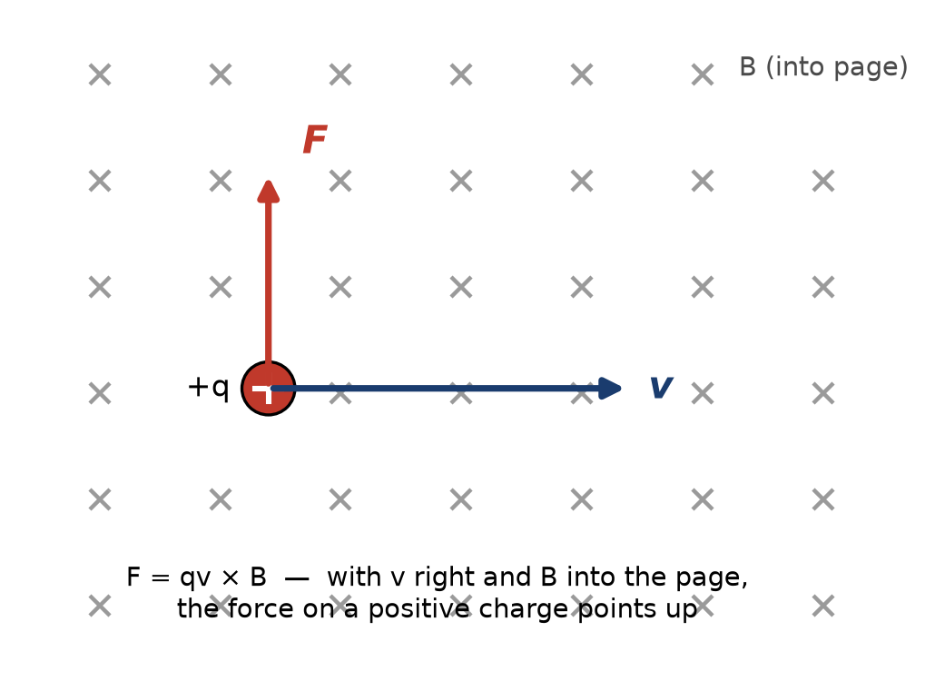
Figure 9.1 — A positive charge moving right through a field pointing into the page feels a force straight up.
Key Idea
A magnetic force can never do work on a charge. Because the magnetic force is always perpendicular to the charge's velocity, it can never have a component along the direction of motion, and force perpendicular to displacement does zero work. A magnetic field can change a charge's direction, but never its speed or its kinetic energy. Any speeding up or slowing down of a charged particle in a real device is always due to an electric field, even in devices — like motors — that are popularly described as “magnetic.”

9.3 Circular Motion in a Uniform Field
Because the magnetic force is always perpendicular to velocity and constant in magnitude for a fixed speed, a charged particle moving perpendicular to a uniform magnetic field travels in a perfect circle, with the magnetic force supplying exactly the centripetal force needed:
qvB = mv²/r ⟹ r = mv / (qB)
This relationship is the operating principle behind mass spectrometers, cyclotrons, and — in a more elaborate form — the particle accelerators used in high-energy physics. It also explains why charged particles from the solar wind spiral around Earth's magnetic field lines rather than striking the atmosphere directly, redirected toward the poles where the field lines converge — the mechanism behind the aurora.
If the particle's velocity has a component along the field direction as well as perpendicular to it, the perpendicular component still produces circular motion exactly as described, while the parallel component is entirely unaffected by the field (since v × B vanishes when v is parallel to B). The combined motion is therefore a helix — a circle that also drifts steadily along the field direction — rather than a closed circle. This helical motion is exactly what channels charged particles along Earth's field lines toward the poles, and it is worth being able to picture clearly.

9.4 The Magnetic Force on a Current-Carrying Wire
A current-carrying wire in a magnetic field experiences a force, because the current is nothing more than a great many moving charges, each individually subject to F = qv × B. Summed over a straight wire segment of length L carrying current I in a uniform field B, the total force is:
F = I L × B
with magnitude F = BIL sinθ, where θ is again the angle between the wire (taken in the direction of conventional current flow) and the field. This is the force that turns the rotor of every electric motor: current-carrying wire loops placed in a magnetic field experience a torque that spins the motor's shaft, a device treated in full once this series reaches its power-and-machines material.

9.5 Units
The SI unit of magnetic field is the tesla (T), defined so that a charge of one coulomb moving at one meter per second, perpendicular to a one-tesla field, experiences a force of one newton. A tesla is a substantial field — Earth's own magnetic field at its surface is roughly 0.00005 T (50 µT), a small fridge magnet might reach 0.01 T, and MRI machines operate in the range of 1–3 T. An older, non-SI unit, the gauss (1 T = 10,000 G), still appears frequently in older texts and in some manufacturer datasheets, and is worth recognizing even though this book uses tesla throughout.
Worked Example 9.1
Problem: A proton moves at 2.0 × 10⁶ m/s perpendicular to a 0.50 T magnetic field. Find the magnitude of the magnetic force on it, and the radius of its circular path.
Solution: F = qvB = (1.60×10⁻¹⁹)(2.0×10⁶)(0.50) ≈ 1.6×10⁻¹³ N. Radius: r = mv/(qB) = (1.67×10⁻²⁷ kg)(2.0×10⁶)/[(1.60×10⁻¹⁹)(0.50)] ≈ 0.042 m, about 4.2 cm.
Worked Example 9.2
Problem: A straight horizontal wire 0.80 m long carries a current of 6.0 A due east. Find the magnitude and direction of the magnetic force on the wire if it sits in a uniform 0.40 T field pointing straight down (toward the ground).
Solution: Magnitude: F = BIL sinθ. The wire (east) and the field (down) are perpendicular, so θ = 90° and sinθ = 1: F = (0.40)(6.0)(0.80) = 1.92 N. Direction, by the right-hand rule for I L × B: point your fingers east (current direction), curl them downward (field direction) — your thumb points north. The force on the wire is therefore 1.92 N directed due north.
Common Misconception
Because the magnetic force involves a cross product, its direction is one of the more error-prone parts of introductory electromagnetism, and a common shortcut error is to assume the force simply points “along” one of the two vectors involved, or splits the difference between them. It does neither: F = qv×B is always exactly perpendicular to both v and B, full stop, regardless of the angle between v and B (as long as that angle is not 0° or 180°, where the cross product vanishes entirely). There is no partial or intermediate direction to reason about — only perpendicular to both, with the right-hand rule fixing which of the two possible perpendicular directions is correct.

Practice Problems
- [Easy] An electron moves at 3.0 × 10⁵ m/s perpendicular to a 0.20 T field. Find the magnetic force on it.
- [Easy] A straight wire 0.50 m long carries a current of 4.0 A, oriented perpendicular to a 0.30 T field. Find the force on the wire.
- [Medium] Explain, in one or two sentences, why a magnetic field can change a charged particle's direction of travel but never its speed.
- [Medium] A proton travels in a circular path of radius 0.10 m in a magnetic field of 0.80 T. Find the proton's speed.
- [Easy] A charge of +5.0 µC moves at 4.0 × 10⁴ m/s perpendicular to a 0.60 T field. Find the magnetic force on it.
- [Medium] An electron moves at 1.0 × 10⁶ m/s at an angle of 30° to a 0.50 T magnetic field. Find the magnitude of the magnetic force on it.
- [Medium] A 0.25 m wire segment carrying a current of 8.0 A is oriented at 40° to a uniform 0.35 T field. Find the magnitude of the force on the wire.
- [Hard] A proton and an alpha particle (charge +2e, mass ≈ 4 times the proton's) move perpendicular to the same magnetic field at the same speed. Find the ratio of their circular path radii, r_α/r_p.
Quick-Check Answers
1. ≈9.6×10⁻¹⁵ N 2. 0.60 N 3. (conceptual — see Appendix B) 4. ≈7.66×10⁶ m/s 5. 0.12 N 6. ≈4.0×10⁻¹⁴ N 7. ≈0.45 N 8. r_α/r_p = 2

Chapter 10 — Sources of the Magnetic Field

10.1 Moving Charge Makes a Field
Chapter 9 described how a magnetic field pushes on moving charge. The complementary fact — and the one that reveals magnetism and electricity as genuinely unified — is that moving charge itself produces a magnetic field. A stationary charge produces only an electric field; the same charge, once set in motion, produces a magnetic field as well, without losing its electric field. Current-carrying wires, not permanent magnets, are the fundamental source of magnetic fields in essentially all of modern electrical engineering; permanent magnets turn out to owe their field to countless aligned electron orbits and spins, which are themselves tiny current loops at the atomic scale.

10.2 The Field of a Long Straight Wire
The magnetic field produced by a long, straight, current-carrying wire circles around the wire, with field lines forming closed circles centered on the wire and lying in planes perpendicular to it. The direction is given by a right-hand rule: point your right thumb in the direction of conventional current, and your curled fingers indicate the field's direction. The field's magnitude at a perpendicular distance r from the wire is:
B = μ₀ I / (2πr)
where μ₀ is the permeability of free space:
μ₀ = 4π × 10⁻⁷ T·m/A
Notice the structural resemblance to the electric field of an infinite line charge from Chapter 4 — both fall off as 1/r rather than the 1/r² of a point source, because both sources are effectively infinite lines rather than points, and the same expanding-geometry argument that gave 1/r for that line charge gives 1/r here as well.

10.3 Force Between Two Parallel Wires
Two parallel current-carrying wires each produce a field that exerts a force on the other, via the F = IL × B relation from Chapter 9. Wires carrying current in the same direction attract; wires carrying current in opposite directions repel — a result many students find backward on first encounter, since it is the reverse of the same-charges-repel rule for static charges. This attraction/repulsion between current-carrying wires was, historically, exact enough to measure that it was used for decades to define the ampere itself, before the 2019 SI redefinition tied the ampere to the elementary charge instead.

10.4 Ampere's Law
Just as Gauss's law provides a shortcut to the electric field for sufficiently symmetric charge distributions, Ampere's law provides the analogous shortcut for the magnetic field of sufficiently symmetric current distributions. It states that the line integral of B around any closed path (an “Amperian loop”) equals μ₀ times the net current enclosed by that path:
∮ B · dl = μ₀ I_{enc}
Applied to a circular Amperian loop of radius r centered on a long straight wire, where by symmetry B is constant in magnitude around the loop and everywhere tangent to it, this reduces immediately to B(2πr) = μ₀I, recovering the result of Section 10.2 with almost no work — exactly the payoff Gauss's law provided for the electric field.

10.5 The Field of a Solenoid
A solenoid — a long coil of wire wound in a tight helix — produces, to a good approximation deep inside the coil (away from its ends), a uniform magnetic field parallel to its axis, closely analogous to the uniform field between parallel-plate capacitor plates. Applying Ampere's law to a rectangular loop that runs partly inside and partly outside the solenoid gives:
B = μ₀ n I
where n is the number of turns of wire per unit length along the solenoid's axis. Solenoids are the standard way to produce a strong, uniform, and controllable magnetic field in a compact region, and they form the physical basis of the inductor, a component taken up in the next chapter of this book.
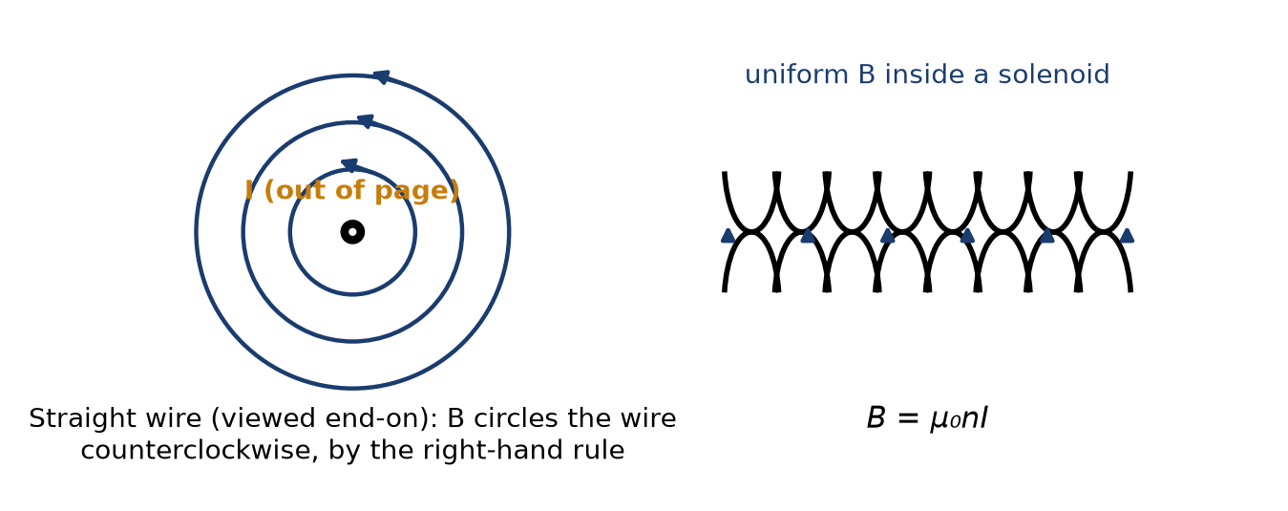
Figure 10.1 — Left: the field circling a wire carrying current out of the page. Right: the uniform field inside a solenoid.

10.6 Ferromagnetic Materials
Placing a ferromagnetic core — iron being the most familiar example — inside a solenoid dramatically increases the resulting field, often by a factor of several hundred to several thousand, because the core's own atomic-scale current loops (electron spins) align with the applied field and add their own contribution to it, in direct analogy with how a dielectric's molecular dipoles respond to an applied electric field (Chapter 6). This effect is captured by replacing μ₀ with an effective permeability μ = μᵣμ₀, where the relative permeability μᵣ can be in the thousands for common transformer-grade iron. This is exactly why practical inductors and transformers are wound around iron or ferrite cores rather than left as air-core coils: the same number of turns and the same current produce a vastly stronger field, or equivalently, a much smaller and lighter coil can produce the field a much larger air-core solenoid would need to match.
Worked Example 10.1
Problem: A long straight wire carries a current of 5.0 A. Find the magnetic field at a distance of 2.0 cm from the wire.
Solution: B = μ₀I/(2πr) = (4π×10⁻⁷)(5.0) / [2π(0.020)] = 5.0 × 10⁻⁵ T — exactly the same order of magnitude as Earth's own field, which is why a compass placed near a current-carrying wire is visibly deflected.
Worked Example 10.2
Problem: A solenoid has 800 turns over a length of 20 cm and carries a current of 2.0 A. Find the magnetic field inside it, and find the new field if an iron core with relative permeability 1500 is inserted.
Solution: Turns per unit length: n = 800/0.20 = 4000 turns/m. Air-core field: B = μ₀nI = (4π×10⁻⁷)(4000)(2.0) ≈ 1.0 × 10⁻² T = 10 mT. With the iron core: B = μᵣμ₀nI = 1500 × 10 mT = 15 T — an enormous field, and in practice, iron cores saturate (their internal alignment reaches a maximum) well before reaching such an extreme value, so this idealized result overstates what a real core would achieve at this current; the qualitative point, that the core provides a three-orders-of-magnitude boost, still holds at more realistic operating currents.
Common Misconception
The like-charges-repel, unlike-charges-attract rule from electrostatics is so deeply ingrained by this point in the book that it is tempting to assume current-carrying wires must follow an analogous rule based on current direction. They do not follow the electrostatic pattern at all: parallel currents in the same direction attract, and parallel currents in opposite directions repel — the reverse of the “same repels, opposite attracts” pattern from charge. The two situations are governed by genuinely different force laws (Coulomb's law versus the magnetic force law), and importing intuition from one to the other, without working through the right-hand rule explicitly, reliably produces the wrong sign.

Practice Problems
- [Easy] Two long parallel wires, 5.0 cm apart, each carry a current of 3.0 A in the same direction. State whether they attract or repel.
- [Easy] A solenoid has 800 turns over a length of 20 cm and carries a current of 2.0 A. Find the magnetic field inside it.
- [Medium] At what distance from a wire carrying 10 A does the magnetic field equal 1.0 × 10⁻⁴ T?
- [Medium] A solenoid produces a field of 8.0 mT with an air core at a given current. Find the field at the same current if a ferrite core of relative permeability 200 is inserted.
- [Easy] Two long parallel wires, 8.0 cm apart, carry currents of 4.0 A in opposite directions. State whether they attract or repel, and find the force per unit length between them.
- [Medium] A solenoid must produce a field of 5.0 mT using a current of 1.5 A with an air core. Find the required number of turns per meter.
- [Medium] Two long parallel wires each carry 6.0 A in the same direction, separated by 3.0 cm. Find the force per unit length between them, and state whether it is attractive or repulsive.
- [Hard] An air-core solenoid produces a field of 12 mT at a given current. An iron core of relative permeability 800 is inserted, but core saturation limits the actual field to only 80% of what the idealized formula B = μᵣμ₀nI would predict. Find (a) the idealized predicted field and (b) the actual field achieved.
Quick-Check Answers
1. Attract 2. ≈1.0×10⁻² T 3. 2.0 cm 4. 1.6 T 5. Repel; F/L ≈ 4.0×10⁻⁵ N/m 6. n ≈ 2.65×10³ turns/m 7. Attract; F/L ≈ 2.4×10⁻⁴ N/m 8. (a) 9.6 T idealized (b) ≈7.68 T actual, once saturation is accounted for

Chapter 11 — Electromagnetic Induction

11.1 Faraday's Discovery
Every result so far in this book's magnetism chapters has concerned static, unchanging current distributions producing static magnetic fields. Michael Faraday discovered, in 1831, something qualitatively new: a changing magnetic field, or a changing magnetic flux through a loop of wire more generally, induces an electromotive force — and hence a current, if the loop is closed — even with no battery anywhere in the circuit. This is electromagnetic induction, and it is, without exaggeration, the single physical fact that makes electric generators, transformers, and power grids possible; without it, essentially all large-scale electricity generation as it currently exists would not work.

11.2 Magnetic Flux
Magnetic flux is defined exactly analogously to electric flux from Chapter 4 — for a flat surface of area A in a uniform field B, oriented so its normal makes angle θ with the field:
Φ_{B} = B A cosθ
with SI unit the weber (Wb), equal to one tesla-meter-squared. It is a change in this quantity — not the field itself, and not even the presence of current — that induction responds to.

11.3 Faraday's Law
Faraday's law states that the induced electromotive force (EMF) around a closed loop equals the negative rate of change of magnetic flux through the loop:
ε = −dΦ_{B}/dt
For a coil of N turns, each threaded by the same changing flux, the induced EMFs from every turn add:
ε = −N dΦ_{B}/dt
Flux can change for several distinct reasons — the field itself changing in time, the loop's area changing, the loop rotating relative to the field, or the loop moving into or out of a field-filled region — and Faraday's law responds identically to all of them, because all of them change Φᵇ. This is precisely how an electric generator works: a coil is mechanically rotated within a magnetic field, continuously changing Φᵇ as the coil's orientation relative to the field changes, producing an alternating EMF — the direct physical origin of the AC waveform this series' circuit-theory volume takes as its starting point.

11.4 Lenz's Law and the Meaning of the Minus Sign
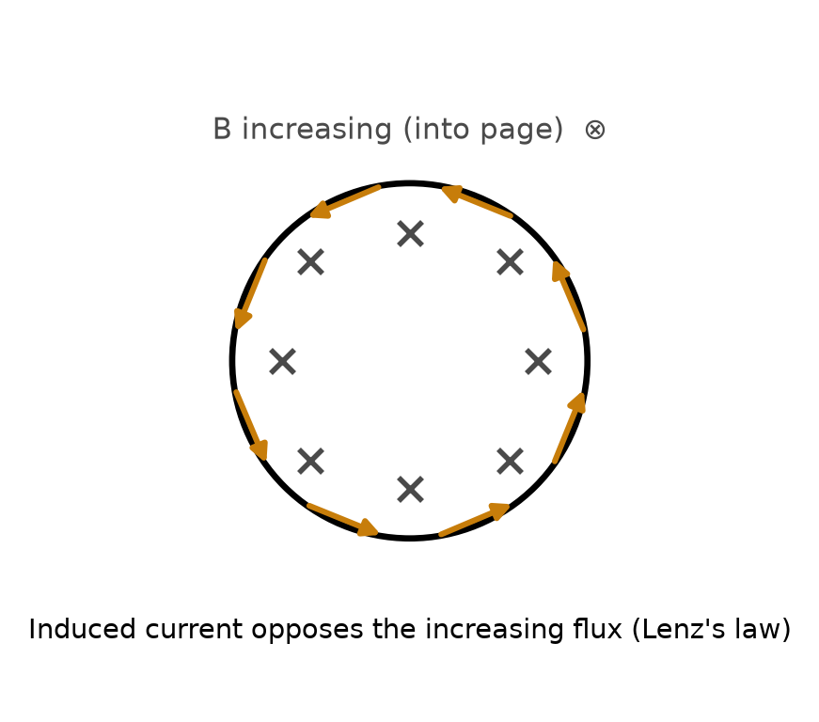
Figure 11.1 — Flux into the page is increasing; the induced current flows counterclockwise to oppose it.
The minus sign in Faraday's law is not a bookkeeping detail — it encodes Lenz's law, one of the more important qualitative facts in this book. Lenz's law states that the induced current always flows in whatever direction opposes the change in flux that produced it. If flux through a loop is increasing, the induced current flows in the direction that would, by the results of Chapter 10, produce a magnetic field opposing that increase; if flux is decreasing, the induced current flows to reinforce it.
Key Idea
Lenz's law is a direct consequence of energy conservation. If induced current instead reinforced a changing flux, the effect would build on its own cause without limit, generating energy from nothing. Lenz's law guarantees that any electromagnetic induction always opposes the mechanical or electrical change that created it — which is precisely why turning a generator's shaft takes real mechanical effort: you are always pushing against an induced magnetic braking force, and that mechanical work is exactly what becomes the electrical energy delivered by the generator.

11.5 Motional EMF
A useful special case: a conducting rod of length L, moving with velocity v perpendicular to a magnetic field B, develops an EMF along its length:
ε = BLv
This can be derived directly from the magnetic force on the rod's own free charges (F = qv×B from Chapter 9) without invoking flux at all, and it is reassuring — and a useful check on your understanding — that both approaches, flux-based and force-based, agree exactly. This is the operating principle behind simple linear generators and behind induced voltages in moving conductors more generally, including eddy currents induced in metal moving through a field, which is exploited deliberately in magnetic braking systems.

11.6 Energy Stored in a Magnetic Field: A First Look at Inductance
Just as a capacitor stores energy in the electric field between its plates (Chapter 6), a current-carrying coil stores energy in its own magnetic field. A coil's ability to do this — to build up a magnetic field, store energy in it, and (by Faraday's law, applied to itself) resist any change in the current that produces it — is quantified by its self-inductance L, defined so that the induced EMF opposing a change in the coil's own current is:
ε = −L dI/dt
with SI unit the henry (H). Notice the structural parallel to Ohm's law and to the capacitor relation C = Q/V: three of this book's core circuit elements — resistor, capacitor, inductor — each relate a pair of circuit quantities (voltage and current, charge and voltage, and now voltage and the rate of change of current) through a single characteristic constant of the component. A full treatment of inductors, RL circuits, and the energy U = ½LI² stored in an inductor's magnetic field belongs properly to the circuit-theory volume of this series, which develops all three of these elements — resistor, capacitor, and inductor — together, once the tools for handling time-varying circuits are in place. What matters here is simply recognizing that Chapter 10's solenoid, once wired into a circuit and thought of as opposing its own changing current via Faraday's law, is exactly what an inductor is.
Worked Example 11.1
Problem: A circular loop of wire, radius 5.0 cm, sits in a magnetic field that increases uniformly from 0.20 T to 0.80 T over 0.30 s, with the field perpendicular to the loop throughout. Find the average induced EMF.
Solution: Loop area: A = πr² = π(0.050)² ≈ 7.85×10⁻³ m². Change in flux: ΔΦ = AΔB = (7.85×10⁻³)(0.80−0.20) = 4.71×10⁻³ Wb. Average EMF: ε = ΔΦ/Δt = 4.71×10⁻³/0.30 ≈ 1.57 × 10⁻² V.
Worked Example 11.2
Problem: A metal rod 0.40 m long slides along a pair of conducting rails, moving at a constant 3.0 m/s, perpendicular to a uniform 0.60 T magnetic field pointing straight into the plane of the rails. Find the motional EMF developed, and state, using Lenz's law, which way current flows in the circuit formed by the rod and rails as the rod moves.
Solution: Motional EMF: ε = BLv = (0.60)(0.40)(3.0) = 0.72 V. To find the current direction with Lenz's law: as the rod slides (say, to the right, into the region enclosed by the rails and rod), the enclosed loop area increases, and since B points into the page, the enclosed flux (into the page) is increasing. The induced current must oppose that increase, meaning it must create its own field pointing out of the page inside the loop — by the right-hand rule for a current loop (Chapter 10), this means the induced current flows counterclockwise as viewed with B pointing into the page toward you.
Common Misconception
Faraday's law is sometimes misremembered as responding to the magnetic field itself, so that a strong but constant field is expected to induce a large EMF. It is the rate of change of flux that matters, not the field's absolute size — a room permeated by an enormous, perfectly steady magnetic field induces no EMF in any wire loop sitting motionless within it, no matter how strong that field is, while a comparatively weak field changing quickly can induce a substantial EMF. The relevant question for any induction problem is always “how fast, and in what way, is the flux through this loop changing?” — never “how strong is the field?” by itself.

Practice Problems
- [Easy] A flat coil of 50 turns and area 0.020 m² sits perpendicular to a magnetic field that changes at a rate of 0.50 T/s. Find the induced EMF.
- [Easy] A conducting rod 0.30 m long moves at 4.0 m/s perpendicular to a 0.50 T field. Find the motional EMF developed along the rod.
- [Medium] A bar magnet is pushed, north pole first, toward a loop of wire. Using Lenz's law, state the direction of the induced current in the loop (as viewed from the approaching magnet's side) and explain your reasoning.
- [Medium] An inductor with L = 0.20 H carries a current that is changing at a rate of 5.0 A/s. Find the magnitude of the induced EMF across the inductor.
- [Easy] A flat coil of 100 turns and area 0.015 m² sits perpendicular to a field that changes at a rate of 0.80 T/s. Find the induced EMF.
- [Medium] A square loop of side 0.10 m is pulled out of a uniform 0.90 T field (perpendicular to the loop) at a constant 1.5 m/s, with one side of the loop still inside the field region. Find the magnitude of the induced EMF while the loop is partway out.
- [Medium] A 5.0 Ω resistor is connected across the ends of the rod from Problem 2 (treat the rod itself as resistance-free). Find the current through the resistor.
- [Hard] An inductor with L = 0.50 H carries a steady current of 4.0 A, which is then reduced to zero uniformly over 0.10 s. Find (a) the magnitude of the induced EMF during the decrease, and (b) the energy originally stored in the inductor's magnetic field, briefly explaining where that energy goes as the current drops to zero.
Quick-Check Answers
1. 0.50 V 2. 0.60 V 3. Counterclockwise, viewed from the magnet's side (the loop's near face becomes an effective north pole, repelling the approaching magnet) 4. 1.0 V 5. 1.2 V 6. ≈0.135 V 7. 0.12 A 8. (a) 20 V (b) 4.0 J, dissipated as heat (or a spark) somewhere in the circuit — the source of the voltage spikes seen when inductive current is switched off abruptly

Chapter 12 — Toward Maxwell's Equations and the Rest of This Series

12.1 Gathering the Pieces
This book has built up electricity and magnetism largely as two separate stories that occasionally touch — first electrostatics (Chapters 1–6), then steady currents and resistance (Chapters 7–8), then magnetostatics (Chapters 9–10), then the one genuine crossover result, electromagnetic induction (Chapter 11). James Clerk Maxwell's achievement, completed in 1865, was to recognize that four equations — two of which you have already met by name — form a complete, self-consistent description of every electric and magnetic phenomenon covered in this book, and a great many that are not.

12.2 Maxwell's Four Equations, Informally Stated
- Gauss's law for electricity (Chapter 4): electric field lines originate on positive charge and terminate on negative charge; the total flux through any closed surface measures the net enclosed charge.
- Gauss's law for magnetism (not previously stated by this name, but implicit in every field-line diagram drawn in Chapters 9–10): magnetic field lines never begin or end anywhere — there is no such thing as an isolated magnetic “charge,” or magnetic monopole. Every magnetic field line that leaves a region must loop back into it somewhere.
- Faraday's law (Chapter 11): a changing magnetic flux induces an electric field (which in a conducting loop drives a current, but the induced electric field exists even without a wire present to carry current).
- Ampere's law, with Maxwell's own correction (a term beyond Chapter 10's scope, called the displacement current): a changing electric flux, in addition to actual current, also produces a magnetic field.
It is that final correction — the displacement current, Maxwell's own contribution to a law that already bore Ampere's name — that completes the symmetry between the third and fourth equations and, in doing so, predicts something neither Faraday nor Ampere had any reason to expect: a changing electric field creates a magnetic field, which if itself changing creates an electric field, which if changing creates another magnetic field, and so on indefinitely, each one regenerating the next without needing any charge or current physically present to sustain it.

12.3 Electromagnetic Waves and Light
Maxwell worked out that this self-sustaining oscillation propagates through empty space at a speed determined entirely by ε₀ and μ₀ — the same two constants that appeared, respectively, in Coulomb's law (Chapter 2) and in the field of a straight wire (Chapter 10), each originally measured in completely unrelated laboratory experiments involving static charges and steady currents:
c = 1 / √(ε₀μ₀)
Plugging in the values from Chapters 2 and 10 gives c ≈ 3.00 × 10⁸ m/s — the measured speed of light, to within experimental precision, computed from two constants that had nothing to do with optics. Maxwell concluded, correctly, that light itself is an electromagnetic wave: a self-propagating oscillation of electric and magnetic fields, and that visible light is merely the narrow band of electromagnetic radiation that happens to be detectable by the human eye. Radio waves, microwaves, infrared, ultraviolet, X-rays, and gamma rays are all the same physical phenomenon at different frequencies — a fact this series returns to in full when it reaches antennas, RF engineering, and wave propagation.
It is worth appreciating how strange this result must have seemed at the time. Nothing about Coulomb's careful measurements of the force between charged pith balls, and nothing about Ampere's measurements of the force between current-carrying wires, had anything ostensibly to do with light. Maxwell's equations were assembled entirely from static- and steady-current experiments, plus Faraday's induction results, and yet the mathematics of that assembled system — quite without being asked to — produced a wave equation whose predicted propagation speed matched light exactly. This is among the most celebrated instances in the history of physics of a purely mathematical consequence of an existing theory turning out to describe something no one had built the theory to explain in the first place, and it is difficult to overstate how strong a piece of evidence this was, historically, that Maxwell's four equations were not merely a convenient summary of known results but a genuinely complete and correct description of electromagnetism.
Key Idea
Every subsequent book in this series is, in a real sense, a set of special cases of Maxwell's four equations. DC circuit theory is Maxwell's equations in the limit where nothing changes in time. AC circuit theory is Maxwell's equations for fields that oscillate slowly enough that a circuit's physical dimensions are much smaller than the wavelength involved. RF and antenna theory is what happens once that assumption stops holding. Semiconductor device physics governs how real materials respond to the fields Maxwell's equations describe. There is, in an important sense, only one subject in this entire series — this book has simply built it from the ground up.

12.4 A Historical Aside: Waves Need Something to Wave
Nineteenth-century physicists, having only ever encountered waves that traveled through a physical medium — sound through air, ripples through water — found it almost unthinkable that an electromagnetic wave could travel through genuinely empty space with nothing there to do the waving. This led to decades of searching for the “luminiferous aether,” a hypothesized medium presumed to fill all of space specifically so that light would have something to be a wave in. The most famous search for it, the Michelson-Morley experiment of 1887, attempted to detect Earth's motion through this aether by comparing the speed of light in different directions, and found — to the considerable surprise of everyone involved — no difference whatsoever. It would take Einstein's 1905 special theory of relativity, built in part directly on this null result, to explain why: the speed of light is the same in every direction and in every reference frame, precisely because it is not a wave propagating through any medium at all, but a self-sustaining disturbance in the electric and magnetic fields themselves, exactly as Maxwell's equations describe, needing no material substance to carry it. The aether was never found because there was never anything there to find — but the search for it, and its eventual resolution, is a useful reminder that even a spectacularly successful theory (and Maxwell's equations remain, in their domain, exactly correct today) can still coexist for decades with a widely-held, entirely wrong assumption about what that theory actually implies.

12.5 Where This Series Goes Next
The next book in this series, on DC and AC circuit theory, takes the definitions built here — charge, current, voltage, resistance, capacitance, and (in the closing sections of this book) inductance and induced EMF — and develops the systematic tools (Kirchhoff's laws, Thevenin and Norton equivalents, phasor analysis for AC) needed to analyze real circuits of arbitrary complexity. From there, the series proceeds to semiconductor physics and devices, then to the specialized branches — RF and microwave engineering, digital electronics, power systems, control theory, and communications — that make up the working vocabulary of a practicing electrical engineer. Every one of those later books assumes the physical vocabulary built in this one: charge, field, potential, current, resistance, capacitance, magnetic field, and induction. If any of it still feels unfamiliar, this is the book to return to.

End-of-Book Review Problems
- [Easy] State, in your own words, the physical difference between the electric field and the electric potential at a point in space.
- [Medium] Explain why Gauss's law and Coulomb's law are considered physically equivalent, even though one is stated as an integral over a closed surface and the other as a force between two points.
- [Medium] A capacitor and a resistor are both circuit elements that oppose current in some sense. Explain the physical difference between what each one actually does to the energy delivered to it.
- [Medium] Explain, using Lenz's law, why an electric generator becomes harder to turn by hand as more electrical load (more current draw) is placed on it.
- [Medium] Using the two constants ε₀ and μ₀, and without looking up the value, explain in words how Maxwell was able to compute the speed of light from experiments that involved neither light nor optics.
- [Medium] An inductor resists changes in current, much as a capacitor resists changes in voltage. Explain briefly why these two statements are, in a loose sense, mirror images of each other, referring back to how each component is defined.
- [Easy] A charge is released from rest in a region of uniform electric field. Describe what happens to it in terms of both force and potential, and state whether it moves toward higher or lower potential.
- [Medium] Two students disagree about whether a stationary charge sitting in a strong magnetic field feels any force at all. Referring back to the field definitions in Chapters 3 and 9, explain who is correct and why.
- [Medium] Explain, using the Gauss's-law parallel drawn in this chapter, why Ampere's law is especially useful for an infinite straight wire but not nearly as directly useful for a short, finite wire segment.
- [Hard] Chapter 6 gives a capacitor's stored energy as U = ½CV², and Chapter 11 gives an inductor's stored energy as U = ½LI². Using structural reasoning rather than a derivation, explain why it makes sense that these two formulas share the same mathematical form, referring back to the general pattern noted in Section 11.6 relating resistors, capacitors, and inductors.
Quick-Check Answers
1. Field is a vector (force per charge); potential is a scalar (energy per charge) 2. Same physics, two equivalent mathematical forms, linked via flux and divergence 3. A resistor dissipates energy irreversibly as heat; a capacitor stores it and can return it 4. More load current → a stronger opposing induced field → more mechanical effort to keep turning 5. ε₀ (from Coulomb's law) and μ₀ (from Ampere's law) combine as c = 1/√(ε₀μ₀), matching light's measured speed with no optical measurement involved 6. Capacitors resist rapid voltage change; inductors resist rapid current change — a genuine mirror-image pair 7. A positive charge moves toward lower potential (releasing energy); a negative charge moves toward higher potential 8. No force at all — F = qv×B requires motion, and v = 0 gives F = 0; only an electric field, if present, would act on it 9. An infinite wire's symmetry lets B be pulled out of the loop integral as a constant; a finite segment has no such symmetry, so Ampere's law alone can't isolate B there 10. C and L are both linear, non-dissipative (energy-storing) elements, so their energy formulas share the same generic ½(constant)(variable)² form — the same pattern behind a spring's U = ½kx²

Appendix A — Formula Reference

SI Prefixes
These prefixes recur throughout this book and throughout the rest of this series, and it is worth having the full range fixed firmly in mind rather than only the two or three you happen to use most often — a stray factor of a thousand, misread from an unfamiliar prefix, is one of the most common sources of an answer that is wrong by several orders of magnitude despite every other step being correct.
Prefix | Symbol | Factor
tera | T | 10¹²
giga | G | 10⁹
mega | M | 10⁶
kilo | k | 10³
(none) | — | 10⁰
milli | m | 10⁻³
micro | µ | 10⁻⁶
nano | n | 10⁻⁹
pico | p | 10⁻¹²
femto | f | 10⁻¹⁵

Electrostatics
Quantity | Formula
Coulomb's law | F = kq₁q₂/r² , k = 8.99×10⁹ N·m²/C²
Electric field (point charge) | E = kq/r²
Electric field, force | E = F/q₀
Gauss's law | Φᴇ = Qₑₙᴄ/ε₀
Field, infinite sheet | E = σ/(2ε₀)
Field, infinite line | E = λ/(2πε₀r)
Potential (point charge) | V = kq/r
Potential energy (pair) | U = kqQ/r
Field ↔ potential (uniform) | E = ΔV/d

Capacitance
Quantity | Formula
Capacitance | C = Q/V
Parallel plate | C = ε₀A/d (with dielectric: κε₀A/d)
Energy stored | U = ½CV² = ½QV = Q²/(2C)
Capacitors in parallel | Cₚ = C₁ + C₂ + …
Capacitors in series | 1/Cₛ = 1/C₁ + 1/C₂ + …

Current, Resistance, and Circuits
Quantity | Formula
Current | I = dQ/dt
Current density, drift velocity | J = I/A = nqv_d
Resistance | R = ρL/A
Ohm's law | V = IR
Power | P = IV = I²R = V²/R
Series resistors | Rₛ = R₁ + R₂ + …
Parallel resistors | 1/Rₚ = 1/R₁ + 1/R₂ + …

Magnetism
Quantity | Formula
Magnetic force on charge | F = qv×B , F = qvB sinθ
Force on current-carrying wire | F = IL×B , F = BIL sinθ
Radius of circular motion | r = mv/(qB)
Field of a long straight wire | B = μ₀I/(2πr) , μ₀ = 4π×10⁻⁷ T·m/A
Field inside a solenoid | B = μ₀nI (with core: μᵣμ₀nI)
Ampere's law | ∮ B·dl = μ₀Iₑₙᴄ

Induction
Quantity | Formula
Magnetic flux | Φʙ = BA cosθ
Faraday's law | ε = −N dΦʙ/dt
Motional EMF | ε = BLv
Self-inductance | ε = −L dI/dt
Speed of light | c = 1/√(ε₀μ₀) ≈ 3.00×10⁸ m/s

Appendix B — Practice Problem Solutions
Full solutions to every practice problem in the book are given below, organized by chapter. Attempt each problem in full before consulting its solution here — see the Preface for why this matters more than it might seem to.

Chapter 1 Solutions
1. q = −8.0 nC = −8.0×10⁻⁹ C. Number of excess electrons n = |q|/e = (8.0×10⁻⁹)/(1.602×10⁻¹⁹) ≈ 5.0 × 10¹⁰ electrons.
2. Total charge before contact: +6.0 + (−2.0) = +4.0 nC. Since the spheres are identical, this total splits evenly on contact: each sphere ends with +2.0 nC.
3. Charge moved: Q = IΔt = (2.0 A)(60 s) = 120 C. Number of elementary charges: n = Q/e = 120/(1.602×10⁻¹⁹) ≈ 7.5 × 10²⁰ charges.
4. First contact: neutral sphere touches a sphere at +9.0 nC. Total +9.0 nC splits evenly: each ends at +4.5 nC. Second contact: that same sphere (now +4.5 nC) touches a sphere at −3.0 nC. Total: +4.5 + (−3.0) = +1.5 nC, splitting evenly to +0.75 nC each. Final state: first sphere +4.5 nC, second sphere +0.75 nC, third sphere +0.75 nC.
5. n = q/e = (3.2×10⁻¹⁸)/(1.602×10⁻¹⁹) = 20 elementary charges.
6. Total charge before contact: −12 + 4.0 = −8.0 nC. Splitting evenly between two identical spheres: −4.0 nC each. The sphere that started at +4.0 nC flips sign (positive to negative); the sphere that started at −12 nC does not change sign, only magnitude (12 nC down to 4.0 nC).
7. Positive. The rod's negative charge repels the sphere's free electrons, which flow out through the ground wire while it is connected, leaving the sphere with a deficit of electrons (i.e., a net positive charge) concentrated on the side away from the rod. Removing the ground wire first traps that electron deficit in place; removing the rod afterward lets the remaining positive charge redistribute evenly over the whole sphere, leaving it permanently positively charged — opposite in sign to the inducing rod.
8. Number of electrons: n = Q/e = 1.0/(1.602×10⁻¹⁹) ≈ 6.24×10¹⁸ electrons. Mass: m = n × (9.11×10⁻³¹ kg) ≈ 5.69×10⁻¹² kg, about 5.7 picograms. Even a full coulomb's worth of excess electrons — an enormous charge by everyday standards — has a genuinely negligible mass, confirming that charging an object never noticeably changes how much it weighs.

Chapter 2 Solutions
1. F = kq₁q₂/r² = (8.99×10⁹)(4.0×10⁻⁶)(6.0×10⁻⁶)/(0.30)² ≈ 2.4 N, attractive (opposite signs), directed along the line joining the charges.
2. Set F = kq²/r² = 1.0 N and solve for r: r = √(kq²/F) = √[(8.99×10⁹)(1.0×10⁻⁶)²/1.0] ≈ 0.095 m, about 9.5 cm.
3. Force from +2.0 µC (10 cm away) on the −3.0 µC middle charge: attractive, pulling toward x = 0, magnitude F₁ = k(2.0×10⁻⁶)(3.0×10⁻⁶)/(0.10)² ≈ 5.39 N. Force from +1.0 µC (10 cm away) on the middle charge: attractive, pulling toward x = 20 cm, magnitude F₂ = k(1.0×10⁻⁶)(3.0×10⁻⁶)/(0.10)² ≈ 2.70 N. These act in opposite directions; net force is 5.39 − 2.70 ≈ 2.7 N, directed toward x = 0.
4. Forces on one sphere: gravity mg (down), string tension T (along the string), and Coulomb repulsion F_e = kq²/r² (horizontal, pushing the spheres apart). At equilibrium, T cos(10°) = mg and T sin(10°) = F_e; dividing eliminates T: tan(10°) = F_e/(mg), so kq²/r² = mg tan(10°), where r is related to the string length ℓ by r = 2ℓ sin(10°). This equation, once ℓ is specified, can be solved for q.
5. F = kq²/r² = (8.99×10⁹)(2.0×10⁻⁶)²/(1.0)² ≈ 0.036 N, repulsive.
6. Rearranging F = kq₁q₂/r²: q₂ = Fr²/(kq₁) = (0.20)(0.15)²/[(8.99×10⁹)(5.0×10⁻⁶)] ≈ 1.0×10⁻⁷ C ≈ 0.10 µC.
7. Take charges at the corners of a square of side a = 0.20 m. Each of the two adjacent (side) charges exerts a force of magnitude F_side = kq²/a² = (8.99×10⁹)(3.0×10⁻⁶)²/(0.20)² ≈ 2.02 N on the corner charge, directed along the two sides (perpendicular to each other). These combine, by the Pythagorean theorem, to a resultant of √2 × 2.02 ≈ 2.86 N directed along the diagonal, outward from the square. The diagonal charge, at distance a√2 ≈ 0.283 m, contributes an additional F_diag = kq²/(2a²) ≈ 1.01 N along the same diagonal direction, adding directly (same line, same direction): total ≈ 2.86 + 1.01 ≈ 3.87 N, directed diagonally outward through that corner.
8. Using the small-angle approximation, each string's horizontal displacement from vertical is half the separation: sinθ ≈ (d/2)/L = (0.03)/(0.50) = 0.06, and tanθ ≈ sinθ for small angles. From problem 4's equilibrium condition, F_e = mg tanθ = (0.0020 kg)(9.8 m/s²)(0.06) ≈ 1.18×10⁻³ N. Solving F_e = kq²/d² for q: q = √(F_e d²/k) = √[(1.18×10⁻³)(0.06)²/(8.99×10⁹)] ≈ 2.2×10⁻⁸ C, about 22 nC on each sphere.

Chapter 3 Solutions
1. E = kq/r² = (8.99×10⁹)(12×10⁻⁹)/(0.10)² ≈ 1.08 × 10⁴ N/C, directed radially inward (toward the negative charge).
2. Each charge is 2.0 cm from the midpoint. As in Worked Example 3.2, the fields from a +q and −q pair point the same direction at the midpoint between them: E₁ = E₂ = kq/r² = (8.99×10⁹)(5.0×10⁻⁹)/(0.020)² ≈ 1.12×10⁵ N/C each, adding to a total of about 2.25 × 10⁵ N/C, directed from the positive charge toward the negative one.
3. F = qE = (1.60×10⁻¹⁹)(500) = 8.0×10⁻¹⁷ N. Since the electron's charge is negative, the force is opposite to E — i.e., in the −x direction.
4. τ = pE sinθ = (2.0×10⁻²⁹)(3.0×10⁵) sin(90°) = 6.0×10⁻²⁴ N·m.
5. E = kq/r² = (8.99×10⁹)(6.0×10⁻⁹)/(0.20)² ≈ 1.35×10³ N/C, directed radially outward.
6. At the midpoint, each +8.0 nC charge is 5.0 cm away. Both fields point away from their own source charge — one points toward the midpoint from the left, the other points toward the midpoint from the right — so at the midpoint itself, the two fields point in opposite directions with equal magnitude and cancel exactly: E_net = 0. This is the opposite of the dipole case (problem 2), where the +q and −q fields point the
7. E = F/q, tracking sign carefully: magnitude E = F/|q| = (2.4×10⁻⁵)/(4.0×10⁻⁹) = 6.0×10³ N/C. Since the charge is negative and the force on it is in +y, the field itself (which a negative charge always feels a force opposite to) must point in −y.
8. Each charge produces a field of magnitude E = kq/r² = (8.99×10⁹)(2.0×10⁻⁶)/(0.15)² ≈ 7.99×10⁵ N/C at the third corner. By the geometry of an equilateral triangle, the two field vectors (each pointing away from its own source charge) meet at a 60° angle at the third corner. Combining them: E_net = √(E₁² + E₂² + 2E₁E₂cos60°) = E√3 ≈ (7.99×10⁵)(1.732) ≈ 1.38×10⁶ N/C, directed along the triangle's axis of symmetry, away from the side joining the two charges.

Chapter 4 Solutions
1. By Gauss's law, Φᴇ = Qₑₙᴄ/ε₀ = (2.0×10⁻⁹)/(8.85×10⁻¹²) ≈ 226 N·m²/C. Notice the sphere's radius (3.0 cm) is irrelevant to the answer — flux through a closed surface depends only on enclosed charge, not on the surface's size or shape.
2. E = σ/(2ε₀) = (4.0×10⁻⁶)/[2(8.85×10⁻¹²)] ≈ 2.26 × 10⁵ N/C. Note this does not depend on the 2.0 cm distance given — the field of an ideal infinite sheet is the same at every distance.
3. If the field at a conductor's surface had any component parallel to the surface, that component would push the conductor's free surface charges to redistribute along the surface until they cancelled it out — a process that continues until no field component remains parallel to the surface, i.e., until the field is purely perpendicular to it. This is simply the definition of electrostatic equilibrium applied at the surface.
4. E = λ/(2πε₀r) = (5.0×10⁻⁹)/[2π(8.85×10⁻¹²)(0.040)] ≈ 2.25 × 10³ N/C, directed radially away from the wire.
5. Φₑ = Qₑₙᴄ/ε₀ = (−5.0×10⁻⁹)/(8.85×10⁻¹²) ≈ −565 N·m²/C. The cube's 10 cm side length never enters the calculation, and neither would any other shape enclosing the same charge — Gauss's law only ever cares about the net charge inside the surface, not the surface's geometry.
6. Q = Φₑε₀ = (3.39×10³)(8.85×10⁻¹²) ≈ 3.0×10⁻⁸ C = 30 nC. Again, the 5.0 cm radius given is irrelevant to finding the enclosed charge from the flux.
7. Between the sheets, the two fields point the same direction (away from the + sheet, toward the − sheet) and add: E = σ/ε₀ = (3.0×10⁻⁶)/(8.85×10⁻¹²) ≈ 3.39×10⁵ N/C. Outside either sheet, the two fields point in opposite directions and are equal in magnitude, so they cancel exactly: E = 0. This is the same superposition pattern used for the parallel-plate capacitor in Chapter 6.
8. By symmetry, a Gaussian sphere of radius r < R encloses a fraction (r/R)³ of the total charge (since charge is spread uniformly through the volume, and volume scales as the cube of the radius): Qₑₙᴄ = Q(r/R)³. Gauss's law gives E(4πr²) = Qₑₙᴄ/ε₀ = Q r³/(ε₀R³), so E = Qr/(4πε₀R³) = kQr/R³ — the field grows linearly with r inside the sphere, in contrast to the 1/r² falloff outside it (Worked Example 4.1). At r = R/2: E = kQ(R/2)/R³ = kQ/(2R²).

Chapter 5 Solutions
1. V = kq/r = (8.99×10⁹)(3.0×10⁻⁹)/(0.15) ≈ 180 V.
2. W = ΔU = kqQ/r = (8.99×10⁹)(2.0×10⁻⁹)(5.0×10⁻⁹)/(0.10) ≈ 8.99×10⁻⁷ J.
3. ΔV = Ed = (2.0×10⁴)(0.0050) = 100 V.
4. Kinetic energy gained equals the magnitude of the potential energy lost: KE = |q|ΔV = (1.60×10⁻¹⁹)(500) = 8.0×10⁻¹⁷ J. Speed from KE = ½mv²: v = √(2KE/m) = √[2(8.0×10⁻¹⁷)/(9.11×10⁻³¹)] ≈ 1.33 × 10⁷ m/s (about 4.4% of the speed of light — fast enough that a fully careful treatment would need relativistic corrections, though this book treats it non-relativistically, which is accurate to a few percent at this speed).
5. V = kq/r = (8.99×10⁹)(−4.0×10⁻⁹)/(0.20) ≈ −180 V.
6. Potential is a scalar, so the two contributions simply add rather than needing vector combination: each +4.0 nC charge is 6.0 cm from the midpoint, so V = 2 × kq/r = 2(8.99×10⁹)(4.0×10⁻⁹)/(0.060) ≈ 1.2 × 10³ V. Contrast this with a midpoint between equal and opposite charges (Worked Example 5.2), where the two contributions cancel to give V = 0 instead.
7. W = qΔV = q(V_f − V_i) = (−3.0×10⁻⁹)(−100 − 200) = (−3.0×10⁻⁹)(−300) = 9.0×10⁻⁷ J ≈ 900 nJ, positive — meaning an external agent must supply this energy. This makes sense: the force on a negative charge points opposite the field, i.e., toward higher potential, so a negative charge accelerates on its own toward higher V. Moving it from 200 V down to −100 V goes against that natural tendency, which is why positive work input is required.
8. With three equal charges, the total potential energy is the sum over all three distinct pairs, and by symmetry each pair contributes the same amount: U_pair = kq²/r = (8.99×10⁹)(2.0×10⁻⁹)²/(0.10) ≈ 3.60×10⁻⁷ J. Total: U = 3 × U_pair ≈ 1.08×10⁻⁶ J = 1.08 µJ — the work required to assemble all three charges, bringing them in one at a time from infinity.

Chapter 6 Solutions
1. Q = CV = (4.0×10⁻⁶)(12) = 4.8×10⁻⁵ C = 48 µC. Energy: U = ½CV² = ½(4.0×10⁻⁶)(12)² ≈ 2.88×10⁻⁴ J.
2. With Q fixed and d doubled: C = ε₀A/d is halved. Since V = Q/C and Q is fixed while C is halved, V doubles. Energy U = Q²/(2C): with Q fixed and C halved, U doubles as well — consistent with the fact that pulling the plates apart against their mutual attraction, at fixed charge, requires doing work on the system, which appears as the increase in stored energy.
3. C = κ × 10 pF = 3.5 × 10 pF = 35 pF.
4. Parallel capacitance: C = 2.0 + 4.0 + 4.0 = 10.0 µF. Total charge: Q = CV = (10.0×10⁻⁶)(9.0) = 9.0×10⁻⁵ C = 90 µC.
5. Q = CV = (2.0×10⁻⁶)(50) = 1.0×10⁻⁴ C = 100 µC. U = ½CV² = ½(2.0×10⁻⁶)(50)² = 2.5×10⁻³ J = 2.5 mJ.
6. C = κ × 20 pF = 6.0 × 20 pF = 120 pF. Because the battery keeps V fixed while C increases sixfold, Q = CV must also increase sixfold — the battery supplies the extra charge needed to maintain the same voltage on a now-larger capacitance. (Contrast this with problem 2 and problem 8, where the capacitor is isolated rather than battery-connected, and it is V, not Q, that changes.)
7. Series: 1/C = 1/3.0 + 1/6.0 = 2/6.0 + 1/6.0 = 3/6.0, so C = 2.0 µF. In series, every capacitor carries the same charge: Q = CV = (2.0×10⁻⁶)(12) = 2.4×10⁻⁵ C = 24 µC on each. Individual voltages: V₁ = Q/C₁ = 24 µC/3.0 µF = 8.0 V; V₂ = Q/C₂ = 24 µC/6.0 µF = 4.0 V. Check: 8.0 + 4.0 = 12 V, matching the source, as it must.
8. Before: C₁ = ε₀A/d = (8.85×10⁻¹²)(4.0×10⁻⁴)/(2.0×10⁻⁴) ≈ 17.7 pF; Q = C₁V = (17.7×10⁻¹²)(6.0) ≈ 1.06×10⁻¹⁰ C ≈ 106 pC. After disconnecting the battery, Q stays fixed as d doubles, so C₂ = C₁/2 ≈ 8.85 pF and V₂ = Q/C₂ ≈ 12.0 V (double the original voltage, as problem 2 predicted qualitatively). Energy: U₁ = ½C₁V₁² ≈ 3.19×10⁻¹⁰ J; U₂ = ½C₂V₂² ≈ 6.37×10⁻¹⁰ J — the energy doubles. Since the capacitor is isolated (no battery to supply charge or energy), this extra energy can only have come from mechanical work: the two plates attract each other, so pulling them farther apart requires doing positive work against that attraction, and that work is exactly what appears as the increase in stored field energy.

Chapter 7 Solutions
1. Q = IΔt = (3.0)(5.0) = 15 C.
2. R = ρL/A. Tripling L multiplies R by 3; halving A multiplies R by 2 (since R ∝ 1/A). Combined, R increases by a factor of 3 × 2 = 6.
3. ΔT = 80 − 20 = 60°C. R(T) ≈ R₀[1 + αΔT] = 100[1 + (0.004)(60)] = 100[1.24] = 124 Ω.
4. Equal length and equal resistance means ρ_Cu L/A_Cu = ρ_Al L/A_Al, so A_Cu/A_Al = ρ_Cu/ρ_Al = (1.68×10⁻⁸)/(2.65×10⁻⁸) ≈ 0.634. The copper wire needs roughly 63% of the aluminum wire's cross-sectional area to match its resistance — reflecting copper's lower resistivity, though aluminum's much lower density is exactly why it is still preferred for long-distance overhead power lines despite needing a larger cross-section.
5. Q = IΔt = (2.5)(120) = 300 C.
6. J = I/A: with I fixed and A doubled, J is cut in half. Since J = nqv_d and n, q are fixed properties of the material, v_d ∝ J, so v_d is also cut in half — a wider wire carrying the same current has its charge carriers moving, on average, more slowly.
7. Equal area and equal resistance means ρ_Ag L_Ag/A = ρ_Cu L_Cu/A, so L_Ag/L_Cu = ρ_Cu/ρ_Ag = (1.68×10⁻⁸)/(1.59×10⁻⁸) ≈ 1.057. Silver's resistivity is slightly lower than copper's, so a silver wire can be about 5.7% longer than a copper one of the same thickness and still match its resistance — consistent with silver's reputation as the best ordinary conductor, though its cost keeps copper the practical default.
8. R(2500°C) ≈ R₀[1 + αΔT] = 10[1 + (0.0045)(2480)] = 10[1 + 11.16] ≈ 122 Ω — about 12 times the cold resistance (treat this as an order-of-magnitude estimate; the linear approximation of Section 7.4 is being stretched well past the “modest temperature range” it was derived for, but the qualitative conclusion is the important part here and holds regardless). At the instant a bulb is switched on, the filament is still at room temperature, so its resistance is only R₀ — roughly a twelfth of its hot, steady-state value. By Ohm's law (Chapter 8), the same applied voltage across a much smaller resistance drives a much larger initial current, which decays back down to the normal operating current only as the filament heats up over the next fraction of a second. This inrush current is also exactly why incandescent bulbs so often fail at the moment of switch-on rather than during steady operation.

Chapter 8 Solutions
1. R = V/I = 9.0/0.30 = 30 Ω. Power: P = IV = (0.30)(9.0) = 2.7 W.
2. R_parallel = R₁R₂/(R₁+R₂) = (4.0)(12)/(4.0+12) = 48/16 = 3.0 Ω.
3. From P = V²/R, solve for R: R = V²/P = (5.0)²/0.25 = 100 Ω. This is a minimum resistance — any resistance smaller than 100 Ω would dissipate more than 0.25 W at 5.0 V and exceed the rating.
4. Voltage divider: V₈ₖ = V × R₈ₖ/(R₂ₖ+R₈ₖ) = 10 × 8.0/(2.0+8.0) = 10 × 0.80 = 8.0 V.
5. V = IR = (1.5)(6.0) = 9.0 V. Power: P = I²R = (1.5)²(6.0) = 13.5 W.
6. 1/R = 1/2.0 + 1/3.0 + 1/6.0 = 3/6.0 + 2/6.0 + 1/6.0 = 6/6.0 = 1.0, so R = 1.0 Ω — a useful sanity check is that this combined resistance is smaller than even the smallest individual resistor (2.0 Ω), as parallel resistance always must be.
7. Unloaded, the divider predicts V₂ = V·R/(2R) = 9.0/2 = 4.5 V. With a load resistor R connected in parallel with the bottom resistor, that pair combines to R∥R = R/2, so the total resistance seen by the source becomes R + R/2 = 1.5R, and the tap voltage is now V_tap = V·(R/2)/(1.5R) = 9.0/3 = 3.0 V. Connecting a load pulls the divider's output down from its unloaded value (4.5 V) to a noticeably lower one (3.0 V) — a real and important practical effect, since any voltage divider “sags” once current is actually drawn from its tap point, and the divider's own resistances must be chosen small relative to the expected load to keep this sag acceptable.
8. Maximum power transfer occurs when the load resistance equals the source's internal resistance: R_load = R_internal = 1.0 Ω. At that setting, the total circuit resistance is 1.0 + 1.0 = 2.0 Ω, so I = V/R_total = 12/2.0 = 6.0 A, and the power delivered to the load is P = I²R_load = (6.0)²(1.0) = 36 W. This result — the maximum power transfer theorem — is a standard tool this series returns to explicitly when matching sources to loads.

Chapter 9 Solutions
1. F = qvB = (1.60×10⁻¹⁹)(3.0×10⁵)(0.20) ≈ 9.6×10⁻¹⁵ N.
2. F = BIL = (0.30)(4.0)(0.50) = 0.60 N.
3. The magnetic force F = qv×B is always perpendicular to the particle's velocity v. A force perpendicular to velocity does zero work (since work depends on the force component along the direction of motion), so kinetic energy — and hence speed — cannot change; only the direction of v can be altered.
4. From r = mv/(qB), solve for v: v = rqB/m = (0.10)(1.60×10⁻¹⁹)(0.80)/(1.67×10⁻²⁷) ≈ 7.66 × 10⁶ m/s.
5. F = qvB = (5.0×10⁻⁶)(4.0×10⁴)(0.60) = 0.12 N.
6. F = qvB sinθ = (1.60×10⁻¹⁹)(1.0×10⁶)(0.50)(sin 30°) = (1.60×10⁻¹⁹)(1.0×10⁶)(0.50)(0.50) ≈ 4.0×10⁻¹⁴ N — smaller than it would be at 90°, exactly as expected since sinθ is at its maximum only when velocity and field are perpendicular.
7. F = BIL sinθ = (0.35)(8.0)(0.25)(sin 40°) ≈ (0.35)(8.0)(0.25)(0.643) ≈ 0.45 N.
8. r = mv/(qB), so for the same v and B, r ∝ m/q. Comparing the two: r_α/r_p = (m_α/q_α)/(m_p/q_p) = (4m_p/2e)/(m_p/e) = 4/2 = 2. The alpha particle's radius is twice the proton's — its mass is four times larger, but its charge is only twice as large, so the mass increase wins out and it curves more gently (a larger radius) despite feeling twice the force at any given speed.

Chapter 10 Solutions
1. Parallel currents in the same direction attract.
2. n = 800/0.20 = 4000 turns/m. B = μ₀nI = (4π×10⁻⁷)(4000)(2.0) ≈ 1.0 × 10⁻² T.
3. From B = μ₀I/(2πr), solve for r: r = μ₀I/(2πB) = (4π×10⁻⁷)(10)/[2π(1.0×10⁻⁴)] = 0.020 m, or 2.0 cm.
4. Since B ∝ μᵣ at fixed current and turns, the new field is simply 200 × 8.0 mT = 1600 mT = 1.6 T (again, in practice this idealized scaling would be limited by core saturation at such a high field, as noted in Worked Example 10.2, but the direct proportionality holds as stated for the purposes of this problem).
5. Opposite-direction currents repel. Force per unit length: F/L = μ₀I₁I₂/(2πd) = [μ₀/(2π)]·I₁I₂/d = (2×10⁻⁷)(4.0)(4.0)/(0.080) ≈ 4.0×10⁻⁵ N/m.
6. From B = μ₀nI, solve for n: n = B/(μ₀I) = (5.0×10⁻³)/[(4π×10⁻⁷)(1.5)] ≈ 2.65×10³ turns/m (about 2650 turns per meter of solenoid length).
7. Same-direction currents attract. Force per unit length: F/L = [μ₀/(2π)]·I₁I₂/d = (2×10⁻⁷)(6.0)(6.0)/(0.030) ≈ 2.4×10⁻⁴ N/m.
8. (a) Idealized: B_ideal = μᵣ × 12 mT = 800 × 12 mT = 9600 mT = 9.6 T. (b) With saturation limiting the actual gain to 80% of that idealized prediction: B_actual = 0.80 × 9.6 T ≈ 7.68 T. This is exactly the caveat raised in Worked Example 10.2 made concrete: the linear B = μᵣμ₀nI relation is an excellent approximation at modest fields, but real ferromagnetic cores stop keeping pace with it once their internal alignment approaches its maximum, so any design relying on a large μᵣ at high current should budget for less boost than the idealized formula promises.

Chapter 11 Solutions
1. ε = N(dB/dt)A = (50)(0.50)(0.020) = 0.50 V.
2. ε = BLv = (0.50)(0.30)(4.0) = 0.60 V.
3. As the magnet's north pole approaches, the flux through the loop (in the direction from the magnet toward the loop) is increasing. By Lenz's law, the induced current opposes this increase, so it flows in whatever direction creates a magnetic field opposing the approaching north pole — meaning the loop's near face effectively becomes a north pole itself (like poles repel, resisting the magnet's approach). By the right-hand rule, viewed from the approaching magnet's side, the induced current flows counterclockwise.
4. |ε| = L|dI/dt| = (0.20)(5.0) = 1.0 V.
5. ε = N(dB/dt)A = (100)(0.80)(0.015) = 1.2 V.
6. While the loop is partway out of the field, only the one side still crossing the field boundary contributes a net EMF (the sides fully inside or fully outside the field region either see no changing flux or cancel in pairs), so the flux-based and motional pictures agree: ε = BLv = (0.90)(0.10)(1.5) = 0.135 V.
7. Using the motional EMF from problem 2 (ε = 0.60 V) as the source and treating the rod itself as resistance-free, Ohm's law (Chapter 8) gives the current through the resistor directly: I = ε/R = 0.60/5.0 = 0.12 A.
8. (a) dI/dt = (0 − 4.0)/0.10 = −40 A/s, so |ε| = L|dI/dt| = (0.50)(40) = 20 V — by Lenz's law, this EMF acts in whatever direction tries to maintain the original current, opposing its own decrease. (b) The energy originally stored was U = ½LI² = ½(0.50)(4.0)² = 4.0 J. That energy does not simply disappear as the current is driven to zero — it must be dissipated somewhere in the circuit (typically as heat in whatever resistance is present, or as a spark across any switch contacts that interrupt the circuit abruptly), which is exactly the mechanism behind the large, sometimes damaging voltage spikes seen when current through an inductor is switched off suddenly.

Chapter 12 (End-of-Book Review) Solutions
1. The electric field at a point describes the force per unit charge a test charge would feel there — a vector, with direction. The electric potential at the same point describes the potential energy per unit charge a test charge would have there — a scalar, with no direction, only a numeric value (relative to a chosen reference point, conventionally infinity).
2. Gauss's law and Coulomb's law describe the same underlying physical fact — how a static charge distribution produces an electric field — expressed in two mathematically equivalent forms. Section 4.3 shows explicitly that applying Gauss's law to a spherically symmetric Gaussian surface around a point charge reproduces Coulomb's law exactly; more generally, either law can be derived from the other using the mathematical relationship between a field's flux through a closed surface and its local divergence, which is beyond this book's scope but is a standard result of vector calculus.
3. A resistor dissipates the energy delivered to it as heat, permanently and irreversibly converting electrical energy into thermal energy that leaves the circuit. A capacitor stores the energy delivered to it in its electric field and can return that same energy to the circuit later, undiminished (in the idealized case with no resistive losses) — charging and discharging a capacitor is, in principle, fully reversible, while dissipating energy in a resistor is not.
4. As more load is placed on a generator, more current is drawn from the coil rotating within the magnetic field. By Lenz's law, this increased induced current creates its own magnetic field that opposes the coil's rotation more strongly than before (opposing the very motion that induces it). Overcoming this stronger opposing effect requires more mechanical torque to keep the shaft turning at the same speed, which is felt directly as increased physical effort by whatever is turning it — a turbine, an engine, or a hand crank.
5. Coulomb's law, an experiment purely about the static force between charged objects, gives the value of ε₀. Ampere's measurements of the force between current-carrying wires, an experiment purely about steady currents with no light or optics involved, gives the value of μ₀. Maxwell showed mathematically that combining his four field equations predicts a self-sustaining wave that propagates through empty space at the speed c = 1/√(ε₀μ₀) — and when the already-known values of ε₀ and μ₀ (measured in entirely electrical and magnetic experiments) are plugged into this formula, the result matches the independently measured speed of light, with no light-related measurement having been used anywhere in the calculation.
6. A capacitor's defining relation, C = Q/V, means a capacitor opposes rapid changes in voltage: forcing its voltage to change quickly requires supplying or removing charge quickly, which the surrounding circuit may or may not be able to do. An inductor's defining relation, ε = −L dI/dt, means an inductor opposes rapid changes in current: forcing its current to change quickly induces a large back-EMF resisting that change. In each case, the component “resists” rapid change in the one quantity (voltage for the capacitor, current for the inductor) that does not appear directly in its own defining constant — a genuine mirror-image relationship between the two components that becomes central once both are combined into AC circuits in the next book of this series.
7. The field exerts a force on the charge (F = qE), accelerating it in the direction of E if the charge is positive, or opposite E if it is negative. A positive charge accelerates toward lower potential — it is “falling” in the sense that its potential energy U = qV decreases as it speeds up, exactly mirroring an object falling under gravity. A negative charge does the reverse: it accelerates toward higher potential, since for it, U = qV also decreases as V increases (q itself being negative).
8. The stationary charge feels no magnetic force whatsoever — the magnetic force law from Chapter 9, F = qv×B, depends explicitly on the charge's velocity, and a stationary charge has v = 0, making F = 0 regardless of how strong B is. This is a fundamental difference from the electric field of Chapter 3, which exerts a force on any charge simply for being present, moving or not. If any electric field is also present in the region, the stationary charge would still feel that force — the two fields act by genuinely different rules.
9. Ampere's law is always true, but it is only directly solvable for B when enough symmetry exists to argue that B has constant magnitude (and a known, convenient direction) everywhere along some closed loop, letting it be pulled out of the integral ∮B·dl as in Section 10.4. An infinite straight wire has exactly this symmetry: every point on a circular loop centered on the wire is equivalent by rotation, so B must be the same there. A short, finite wire segment has no such symmetry — the field at a given point depends on distance and angle to every part of the finite wire in a way that varies from point to point along any loop you could draw, so Ampere's law, though still exactly true, cannot be solved for B by symmetry alone; a full treatment requires the more general Biot–Savart approach, beyond this book's scope.
10. Section 11.6 already noted that the resistor, capacitor, and inductor each relate a pair of circuit quantities through a single characteristic constant (V = IR, C = Q/V, ε = −L dI/dt). Of these three, the capacitor and inductor are specifically the non-dissipative, energy-storing elements — nothing is lost to heat in either one, in the idealized case — while the resistor is the one dissipative element. For any element that stores energy through a simple linear proportionality between two quantities (charge and voltage for a capacitor, flux linkage and current for an inductor), the stored energy generically works out to one-half the proportionality constant times the square of the associated variable — precisely the same structural pattern that gives a spring its potential energy U = ½kx² from the linear proportionality F = kx in ordinary mechanics. The shared ½(…)² form in U = ½CV² and U = ½LI² is therefore not a coincidence specific to electromagnetism; it is the general signature of any system that stores energy reversibly through a linear relationship between an effort-like and a flow-like variable.

Appendix C — Glossary
Ampere (A) — SI unit of electric current; one coulomb per second.
Ampere's law — Relates the circulation of the magnetic field around a closed loop to the current enclosed by that loop.
Capacitance (C) — The ratio of charge stored to voltage applied across a pair of conductors; measured in farads.
Conductor — A material in which charge (typically electrons) moves freely in response to an electric field.
Coulomb (C) — SI unit of electric charge.
Coulomb's law — The force between two point charges is proportional to the product of the charges and inversely proportional to the square of their separation.
Dielectric — An insulating material placed between a capacitor's plates to increase its capacitance.
Drift velocity — The average velocity of charge carriers in the direction of current flow, superimposed on much larger random thermal motion.
Electric field (E) — Force per unit charge at a point in space; the physical condition set up by charge that a second charge responds to.
Electric flux — A measure of the electric field passing through a given surface.
Electric potential (V) — Potential energy per unit charge; commonly called voltage.
Electromotive force (EMF) — The energy per unit charge supplied by a source (battery, generator, or induction) that drives current around a circuit.
Elementary charge (e) — The smallest unit of free charge, carried by the proton (+e) and the electron (−e).
Equipotential surface — A surface on which every point is at the same electric potential; always perpendicular to the local electric field.
Faraday's law — A changing magnetic flux through a loop induces an electromotive force around that loop.
Ferromagnetic material — A material (such as iron) whose internal atomic-scale current loops align strongly with an applied magnetic field, greatly amplifying it.
Gauss's law — The total electric flux through a closed surface is proportional to the net charge enclosed.
Inductance (L) — A coil's characteristic constant relating the induced EMF opposing a change in its own current to the rate of that current's change.
Insulator — A material in which electrons remain bound to individual atoms and do not conduct appreciable current under ordinary fields.
Lenz's law — The direction of an induced current always opposes the change in magnetic flux that produced it.
Magnetic field (B) — The field that exerts a force on moving charge; measured in tesla.
Magnetic flux — A measure of the magnetic field passing through a given surface; measured in webers.
Ohm's law — For an ohmic material, voltage across it is proportional to the current through it: V = IR.
Permeability of free space (μ₀) — The constant relating magnetic field to the current that produces it in vacuum.
Permittivity of free space (ε₀) — The constant relating electric field to the charge that produces it in vacuum.
Resistance (R) — The opposition a conductor presents to current flow; measured in ohms.
Resistivity (ρ) — An intrinsic material property describing how strongly a material resists current flow, independent of its shape.
Superconductivity — A state, reached below a critical temperature in certain materials, of exactly zero electrical resistivity.
Superposition — The principle that the net force or field from multiple sources is the vector sum of the contributions from each source individually.
Tesla (T) — SI unit of magnetic field.
Volt (V) — SI unit of electric potential; one joule per coulomb.
Voltage divider — A pair of series resistors that splits an applied voltage between them in proportion to their resistances.

Appendix D — Chapter Summaries
The following summaries are meant for review after finishing the book, not as a substitute for reading each chapter in full — they compress each chapter to its central thread, deliberately leaving out the worked examples, misconceptions, and much of the connective reasoning that make the ideas stick on a first read. Use them the way you would use a set of flashcards: to check, a week or a month after finishing a chapter, whether its core idea has actually stayed with you, and to see at a glance how the twelve chapters connect into a single, continuous argument rather than twelve unrelated topics.

Chapter 1 — Electric Charge
Charge is a fundamental property of matter, quantized in units of the elementary charge e, and always conserved. Objects become charged not by creating charge but by moving electrons between materials — by friction, by contact, or by induction. Conductors allow their electrons to move freely; insulators do not. This distinction, purely a matter of how tightly electrons are bound, is the seed from which the entire rest of electrical engineering grows: every subsequent chapter is, in one way or another, a study of what charge does once it is free to move, or of what happens when a field acts on charge that cannot move.

Chapter 2 — Coulomb's Law and the Electric Force
Coulomb's law quantifies the force between two point charges: proportional to the product of the charges, inversely proportional to the square of their separation. The inverse-square form reflects the geometry of a spreading sphere and reappears throughout physics. Superposition — that forces from multiple sources simply add as vectors — is what makes any charge configuration, however complex, tractable in principle, even though the bookkeeping quickly becomes the practical bottleneck rather than the physics itself.

Chapter 3 — The Electric Field
Rather than charges acting on each other directly across empty space, each charge sets up a field that fills the surrounding space, and a second charge responds only to the local field at its own position. This reframing — force as a two-step process, source to field to second charge — resolves the “action at a distance” puzzle and sets up field lines as a way of visualizing both direction (the tangent to the line) and strength (how closely lines are spaced) at a glance.

Chapter 4 — Electric Flux and Gauss's Law
Gauss's law relates the total electric flux through any closed surface to the net charge enclosed, and is exactly equivalent to Coulomb's law — but for symmetric charge distributions (spheres, infinite lines, infinite sheets), it turns what would be a difficult integral into simple algebra by letting you choose a Gaussian surface that matches the distribution's own symmetry. Applied to a conductor, it explains why excess charge sits only on the outer surface and why the field inside a conductor in equilibrium is always exactly zero.

Chapter 5 — Electric Potential Energy and Voltage
Electric potential — voltage — is potential energy per unit charge, a scalar quantity that is almost always more convenient to work with than the field directly, since it adds algebraically with no direction to track. Field and potential are two views of the same physics: the field points in the direction potential falls off fastest, and for a uniform field this reduces to the simple, practically important relation E = ΔV/d. Only potential differences, never an absolute potential, are ever physically meaningful.

Chapter 6 — Conductors, Capacitance, and Dielectrics
A capacitor is any pair of conductors that stores equal and opposite charge at some voltage between them, with capacitance C = Q/V depending only on geometry. The parallel-plate formula C = ε₀A/d (or κε₀A/d with a dielectric) is derived directly from the field of a charged sheet and the field-to-voltage relation of the previous chapter. Capacitors store real energy in their electric field, and — in a rule that inverts the resistor pattern from the next chapter — combine in parallel by simple addition and in series by reciprocal sum.

Chapter 7 — Electric Current and Resistance
Current is the rate at which charge moves past a point, conventionally taken in the direction positive charge would flow, even though in metals it is electrons moving the opposite way. Individual charge carriers drift remarkably slowly; what makes a circuit respond quickly is the field's own rapid propagation, not the carriers' speed. Resistance, R = ρL/A, depends on both geometry and an intrinsic material property, resistivity, which itself depends on temperature — increasing for metals, decreasing for semiconductors, a contrast that hints at the very different physics underlying each.

Chapter 8 — Ohm's Law and a First Look at Circuits
Ohm's law, V = IR, is an empirical rule (not a fundamental law) that holds well for metals and manufactured resistors, though it fails deliberately for diodes and transistors later in this series. Power dissipated in a resistor, P = IV = I²R = V²/R, is converted irreversibly to heat. Resistors combine by direct addition in series and reciprocal sum in parallel — the opposite pattern from capacitors — and a series pair forms a voltage divider, one of the most common sub-circuits in all of electronics.

Chapter 9 — Magnetism and the Magnetic Field
Unlike the electric field, the magnetic field exerts a force only on moving charge, given by F = qv×B: always perpendicular to both velocity and field, and therefore never capable of doing work or changing a particle's speed — only its direction. A charge moving perpendicular to a uniform field travels in a circle; a current-carrying wire, being a great many moving charges together, feels a corresponding force F = IL×B, the mechanism behind every electric motor.

Chapter 10 — Sources of the Magnetic Field
Moving charge does not just respond to magnetic fields — it produces them, unifying electricity and magnetism into a single phenomenon. A long straight wire produces a field falling off as 1/r; two such wires attract if their currents run the same direction and repel if opposite, the reverse of the static-charge rule. Ampere's law provides the same kind of symmetry-exploiting shortcut for magnetic fields that Gauss's law provides for electric fields, most usefully in deriving the uniform field inside a solenoid, whose strength can be amplified enormously by a ferromagnetic core.

Chapter 11 — Electromagnetic Induction
A changing magnetic flux through a loop induces an electromotive force, by Faraday's law, ε = −N dΦʙ/dt — the single fact underlying every electric generator and transformer. Lenz's law, encoded in that minus sign, guarantees the induced current always opposes the change that produced it, a direct consequence of energy conservation. A coil's own self-inductance, quantifying its resistance to changes in its own current, is the first hint of the inductor as a third fundamental circuit element, alongside the resistor and capacitor.

Chapter 12 — Toward Maxwell's Equations
Maxwell's four equations — two versions of Gauss's law, Faraday's law, and a corrected Ampere's law — unify everything in this book into one self-consistent system. Maxwell's own addition, the displacement current, completes a symmetry that predicts self-sustaining electromagnetic waves, propagating at a speed computable from ε₀ and μ₀ alone, that turns out to match the measured speed of light exactly — revealing light itself as an electromagnetic wave, and setting up every later book in this series as, in one way or another, a special case of these same four equations.

